WORKING CLASS INCLUSION:
AUDIENCES, COLLEAGUES & PROGRAMMING

PROGRAMMING SUGGESTIONS

Introduction

Thank you for downloading! As part of the Working-Class Inclusion: Audiences, Colleagues & Programming resource, we have put together a (non-exhaustive!) collection of titles either made by working-class creatives or that tell working-class stories. These films are not meant to be the definitive representation of the working-class experience but a jumping-off point. They can be conversation starters, calls to action, a fun trip out, or a platform for local and/or working-class creatives behind and in front of the screen.

Programme Suggestions

There are lots of different ways that you can make space in your programme for working-class stories and welcome working-class audiences to your venue. Here are just a few examples:

Working-class talent spotlight
You could programme a short season, retrospectives, double-bills or establish a strand of regular screenings spotlighting working-class stories and/or creatives. There are plenty of names to explore: Andrea Arnold, Lynne Ramsay, Alan Clarke, Bill Douglas, Steve McQueen, Samantha Morton, Kim Longinotto, Carol Morley, Danny Boyle, Destiny Ekaragha, Maxine Peake, Christopher Ecclestone, Paddy Considine, Penny Woolcock, Shane Meadows, Antonia Bird, Terence Davies, to name a few!

Local filmmakers, creatives and community groups
Get to know your local filmmaking group(s). If you don’t already, can you provide space for them to screen films in your venue? Connect with creative networks in your area: you never know where you might find working-class filmmakers, writers or actors with projects in the pipeline. They might not be aware of funding and development opportunities and larger networks (or feel comfortable/welcome in those spaces). If inviting first time filmmakers to show and/or talk about their films, check first how familiar they are with your screening space, and offer to show them around and introduce them to any technicians. Don’t assume they know how everything works.

Archive Screenings and Heritage Projects
Local archive screenings are a great way to connect with your communities and explore history and heritage together. You might even find people who were in the films, or that knew people that were, that would love to see those memories on the big screen. You can find a list of national and regional archives here: https://www2.bfi.org.uk/britain-on-film/regional-national-archives

Film Festivals, networks and organisations
Check through festival programmes and speak with the other programmers to see if they have recommendations of working-class stories and creatives they have screened. Be part of the conversation around inclusive working-class programming! Some festivals will programme packages of short films platforming emerging talent from underrepresented backgrounds. Connect with your Film Hubs and regional Talent Execs to partner up and provide talks about routes into film – they will also be connected with new creatives in your region.
Schools
A memorable school trip can stay with someone for a lifetime and, for some pupils, will be their primary source of cultural engagement. If you can accommodate schools, do! Use the opportunity to talk to them about what you do and why you do it - you never know who might get inspired. Some classes make films and will be looking for venues to screen them in. If they would like to invite families, carers and guardians and you have capacity to host, this could become a real highlight of the school year and a great way to welcome lots of different people to your venue.

Family Films
Offering affordable family screenings is another way to provide space for people from a whole range of different backgrounds. If you can, add a little extra to the screening to make your offer stand out. Can you provide a room and some crafting supplies for an hour after, where families can get creative? A member of staff will need to supervise, which is a perfect opportunity to speak with families and find out what activities they are looking for and what films they’d like to see!

Film List

The following list has been put together as a starting point for exploring and programming working-class stories and platforming working-class creatives. We’ve included a mix of features, documentaries and short films to showcase the diversity of perspectives and styles. Not all working-class filmmakers want to make films about the working-class – but some do! – so we have aimed to include a mix of subject here.

Where available, we have provided the distributor and details about screening formats and access materials. Some titles don’t currently have theatrical rights in the UK, or we’ve been unable to confirm them, but are still important works that contribute to the diversity of working-class representation in film.

British + UK Working-Class Stories & Creatives

Short Film

Ackee & Saltfish
Dir: Cecile Emeke / UK / 2014 / 18 mins
A short film that explores urbanism within london, through the prism of an intimate friendship between two black women, rachel & olivia.

Contact: matthew@saylescreen.com

Butterfly Effect
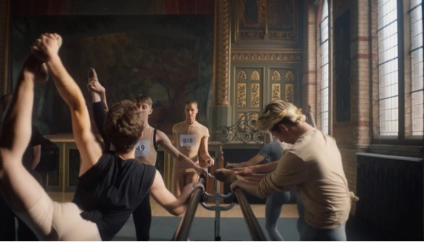
Dir: Edem Wornoo / UK / 2022 / 13 mins

A young black ballet dancer from a South London Council Estate must learn how to survive in two opposing worlds in order to spread his wings.

Fields
Dir: Charlene Wango / UK / 2022
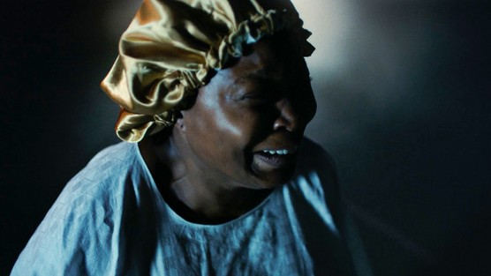
After having a premonition, Pastor Mimi tries to take matters into her own hands to save her son from a tragedy but soon realises it's out of her control.

Haircut
Dir: Koby Adom / UK / 2018 / 15 mins
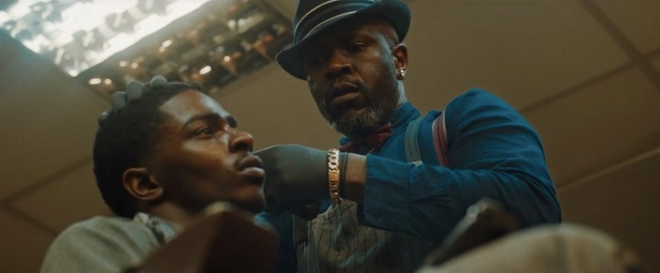
A middle-aged barber must calm the situation when a desperate teenage drug dealer holds up the barbershop at gunpoint.

No Ball Games
Dir: Charlotte Regan / UK / 2020 / 14 mins
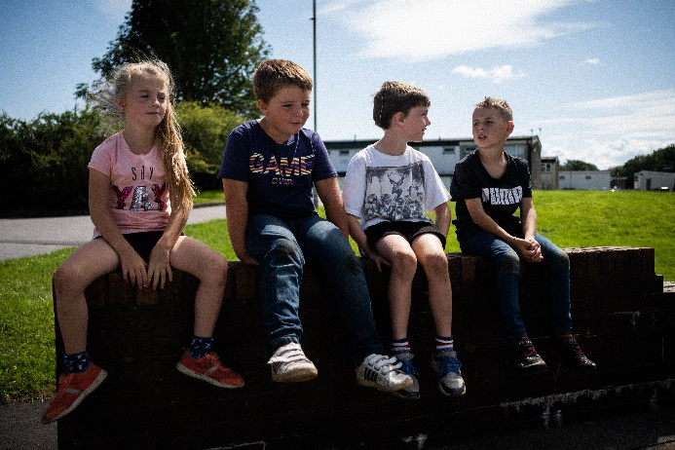
No Ball Games cuts between multiple groups of working-class kids from throughout the UK - a pair of Somalian brothers in Cardiff, a champion kickboxer in Yorkshire, a Roma traveller in Glasgow - and attempts to draw parallels between the way that these children play.
Watch: https://www.theguardian.com/global/video/2020/oct/06/no-ball-games-playing-games-and-life-through-the-eyes-of-children-on-uk-council-estates

Odd Job Alfie: The Documentary
Dir: Aaron Dunleavy / UK / 2018 / 8 mins

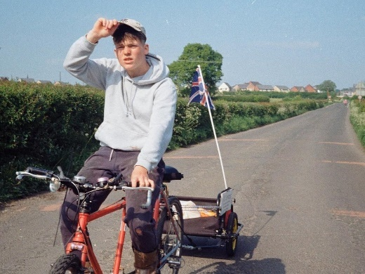
18-year-old Alfie found it hard to hold down a job, so he runs his own business with a tandem bike and a trailer, and has become a bit of a hometown hero
Watch: https://www.youtube.com/watch?v=VwpuGv85tyQ

POP
Dir: Margo Roe / UK / 2021 / 17 mins
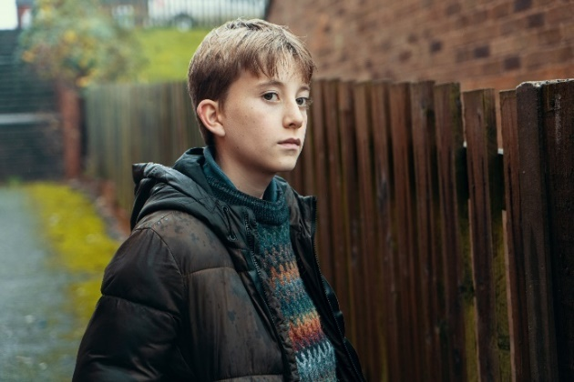
Pop follows a young boy, Jack, as he explores his own identity by befriending the recently released ex-convict, Pop. The pair bond, but Pop's past and his inability to control his emotions threaten to put Jack in danger.

Prosopagnosia
Dir: Steven Fraser / UK / 2021 / 10 mins

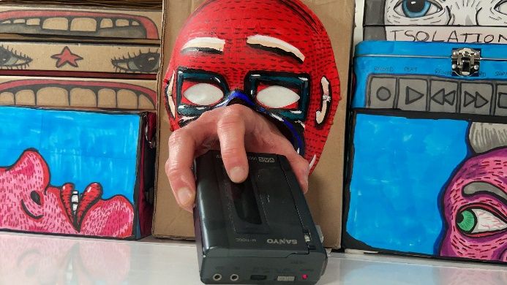
Prosopagnosia uses expressive animation to investigate intimacy, communication and memory. Prosopagnosia means face-blindness and to understand this neurodiverse behaviour, the contents of a memory box are intricately explored. Sketchbooks, photographs and diaries unravel to tell a unique and personal story.

Distributor: festivals@scotdoc.com
Access materials: Descriptive subtitles

Raised By Queenz
Dir: Soph Webberley / UK / 2019 / 4 mins

In the Spring of 2001 in Wolverhampton, a father's adultery guilt sends him to try and explain his absence to his 5-year-old daughter. His daughter, now 23, acknowledges how she feels about being raised by the women in her life and how their struggle has empowered her.

Requiem
Dir: Emma Gilbertson / UK / 2021 / 25 mins
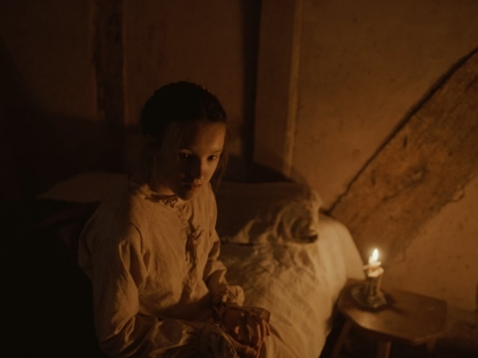
Requiem is set in 1605, against the backdrop of the witch trials. It's a coming of age story, following Evelyn as she engages in a game of cat and mouse against her father, Minister Gilbert, in order to be with Mary, the woman she loves.

Something Said
Dir: Jay Bernard / UK / 2017 / 8 mins
The New Cross Fire was a major tragedy in 1981 that claimed the lives of 13 young black people and was met with state, media and police indifference. Haunted by that history, and in the context of the recent rise of the far-right and the tragedy of Grenfell, Something Said is an imaginative letter to Yvonne Ruddock, the 16 year-old whose birthday was being celebrated the night of the fire.
The Bayview
Dir: Daniel Cook / UK / 2021 / 18 mins
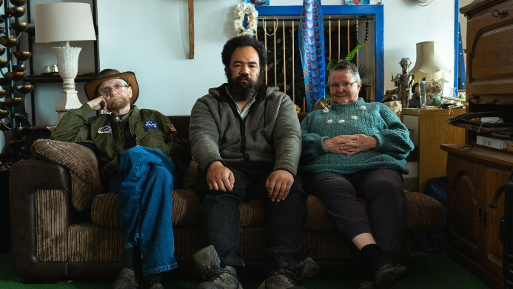
On the North East Coast of Scotland, an extraordinary family have turned the previously derelict Bayview hotel into an unofficial respite for international fishermen. The hotel is crucial to this diaspora community who face life threatening conditions every day. An intimate glimpse into their home and the transient identities who pass through it.

Distributor: festivals@scotdoc.com
Access materials: Descriptive subtitles
The Siren’s Song
Dir: Thomas Longstaff / UK / 2019 / 5 mins
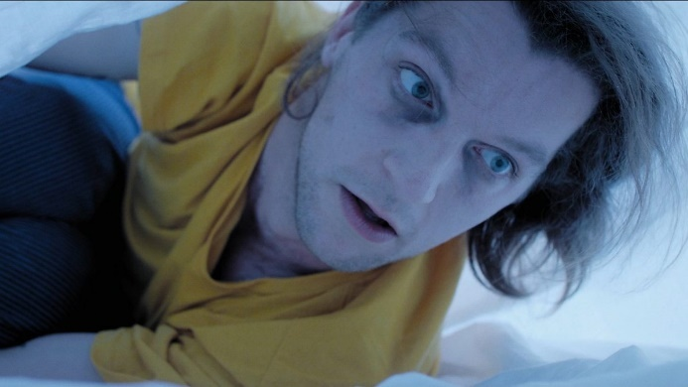
A dark comedy about a young, tired man trying to get up for work, told in the style of an Gothic poem. Sam is woken up by his alarm but struggles against the hypnotic allure of the snooze button. Again and again he succumbs to it, falling deeper and deeper into madness each time he does not get up.

Tight Jeans
Dir: Destiny Ekaragha / UK / 2008 / 9 mins
Three black teenagers are becoming frustrated while waiting for their friend. A young white lad walks past wearing super tight jeans. The boys look on until one of them asks the pivotal question, "How can a man wear jeans that tight?" This sparks a hilarious debate about race and culture.

West Country
Dir: Rowan Ings / UK / 2021 / 9 mins

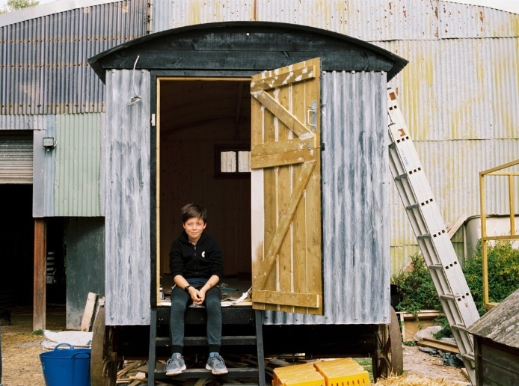
An atmospheric portrait of labour and land in the West Country, told with reflections from local 13-year-old Conor. The film explores daily rhythms of nature and labour, and relationships between men and the land in early Spring.

In 2023, the London Short Film Festival, in association with Underscore Studios, put together a shorts programme called They Call Us the Working Class, with a focus on “elevating working class stories, told by rising working class stars in filmmaking”. Keep an eye out for programmes like this – they are a great way to connect with emerging talent.

Doss House
Dir: Charlotte James / UK / 2022 / 11 mins
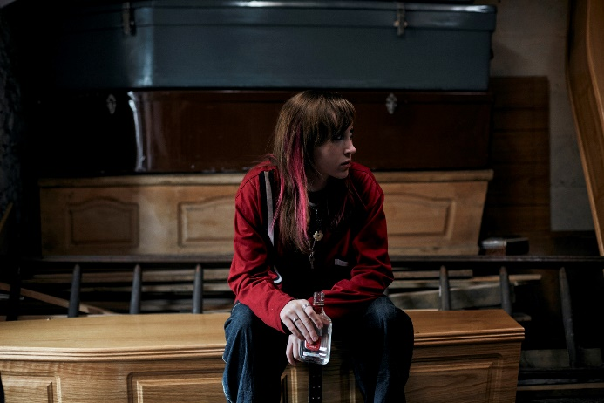
Early 2000s in the Welsh valleys, two best friends Len and Bambi are at the edge of adolescence. They head to a 'party' with an older guy, Jamie. It's an awkward and dark environment and they're soon confronted with the sexual attentions of men many years their senior. Doss House is a stylised drama that explores teenage girls’ experiences of friendship, early romance, and how emerging adulthood is filtered through the lens of male desire.
Format: DCP, MOV/MP4
Access materials: English Subtitles

Home
Dir: Nia Childs / UK / 2022 / 13 mins
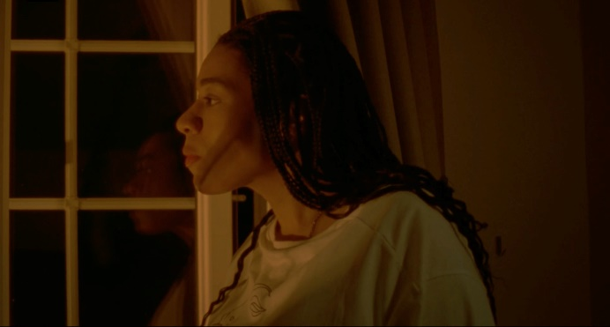
What does it feel like to be free? Kay and Jenna are reuniting for the first time since Kay has been in prison. The lines are blurred as they try to renegotiate their friendship after being kept apart. The film explores how it feels in the immediate days after being released from prison. That surreal window of time where being outside becomes dreamlike, but navigating broken down relationships is confronting. Home explores those quieter moments that are often forgotten when we talk about prison, and uses human relationships to explore themes of friendship, love, and those complicated feelings in between.

Look For The Diamonds
Dir: James Slater / UK / 2022 / 13 mins

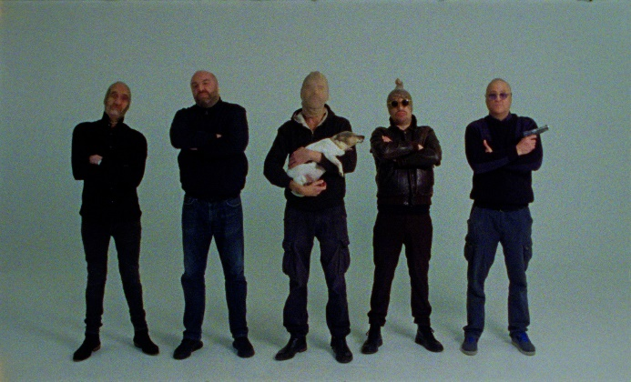
Joel Goldberg has four Kidneys, but none of them work. He has to go on dialysis everyday in order to survive, but he refuses to let his condition define him. Through a uniquely positive outlook on life, Look For The Diamonds shows Joel not just surviving, but living.

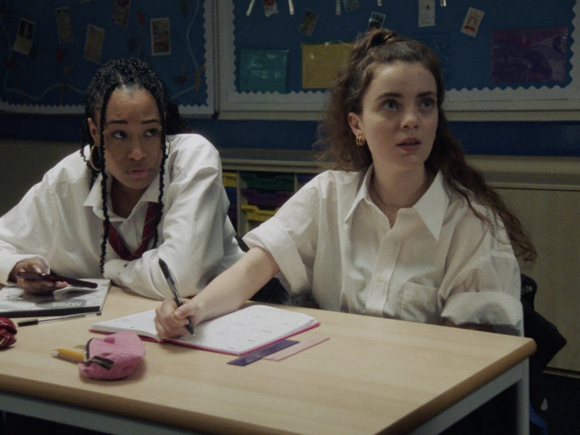
Margin
Dir: Daniel Rands / UK / 2022 / 12 mins
In an after-school, last-chance, catch-up class, 16 year-old student Ria’s struggle to better herself clashes with her teacher Emily’s battle to get through an English lesson evoking racial tensions and societal issues that they soon find to be all too relevant.

Old Windows
Dir: Paul Holbrook / UK / 2022 / UK / 17 mins
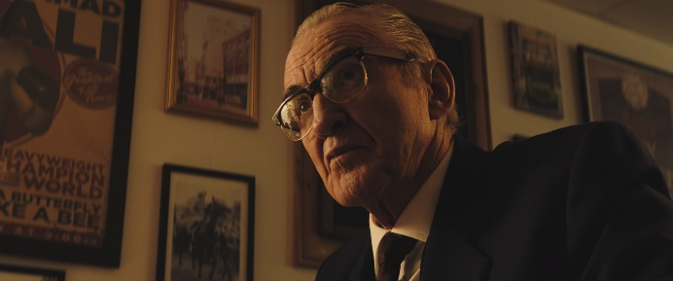
A struggling cafe owner is intrigued when a mysterious, elderly stranger takes an interest in her seemingly mundane life.

Sweet Little Despair
Dir: Carolina Petro / UK / 2021 / 15 mins

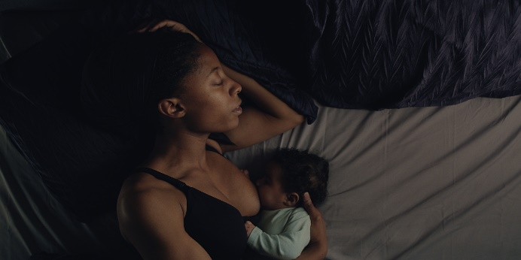
Lynsey juggles her life looking after the elderly at a nursing home and her six-month-old baby. The relentlessness of her routine blur the boundaries between work and personal life, merging her baby and her elderly patients into one and the same.

The Out
Dir: Harry Brandrick / UK / 2021 / 16 mins

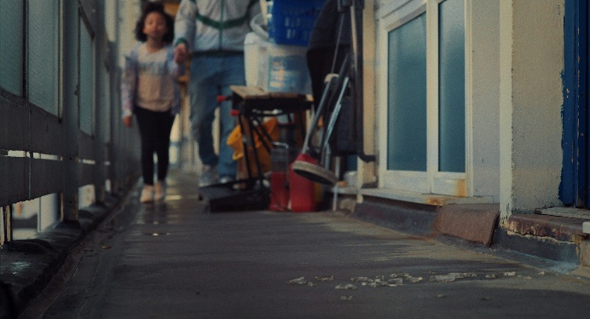
The Out follows Liam, a thirty-five-year-old recovering heroin addict, as he looks after his young daughter for the first time since being out of prison and getting clean. These 24 hours see Liam piecing together the fragments of his life after prison and his complicated journey to recovery.

Documentary

A Bunch of Amateurs
Dir: Kim Hopkins / UK / 2022 / 12A / 95 mins
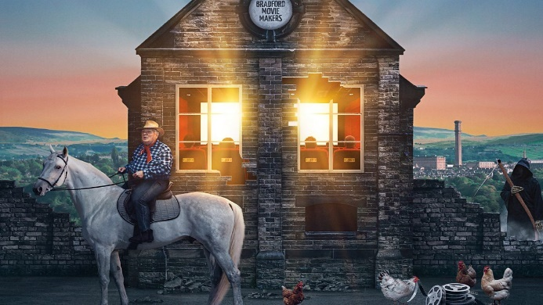
Bradford Movie Makers is one of the oldest amateur filmmaking clubs in the world. Once a thriving community, these days the membership is dwindling and the group struggle to keep the wolf from the door.

Distributor: Republic Film
Access materials: Descriptive subtitles, Audio Description
A Northern Soul
Dir: Sean McAllister / UK / 2018 / 15 / 73 mins
A documentary following a resident of Hull as he attempts to make a positive impact on his community by travelling with a hip-hop tour bus.
Distributor: 101Ft Films
Lyra
Dir: Alison Millar / UK / 2022 / 15 / 91 min
Follows the life of Northern Irish investigative journalist Lyra McKee by telling her story through her own work and words.
Distributor: Wildcard Distribution

McQueen
Dir: Ian Bonhôte, Peter Ettedgui / UK / 2018 / 15 / 111 mins
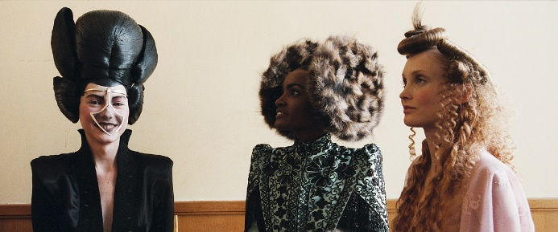
The life and career of fashion designer Lee Alexander McQueen: from his start as a tailor, to launching and overseeing his eponymous line and his untimely death.
Distributor: Lionsgate

Nae Pasaran!
Dir: Felipe Bustos SIerra / UK, Chile / 2018 / 15 / 96 mins

In a Scottish town in 1974, factory workers refuse to carry out repairs on warplane engines in an act of solidarity against the violent military coup in Chile. Four years pass before the engines, left to rust in factory yard, mysteriously disappear in the middle of the night.

Distributor: Cosmic Cat

Rebel Dykes
Dir: Harri Shanahan, Siân A. Williams / UK / 2021 / 18 / 92 mins
REBEL DYKES is a full-length documentary about the explosion that happened when punk met feminism, told through the lives of a gang of lesbians in the riotous London of the 1980s.
Distributor: BFI Distribution/Bohemia Media
Format(s): DCP
Access materials: HOH subtitles / Audio Description (AD)

The Acting Class
Dir: Deirdre O’Neill, Mike Wayne / UK / 2017 / 15 / 77 mins
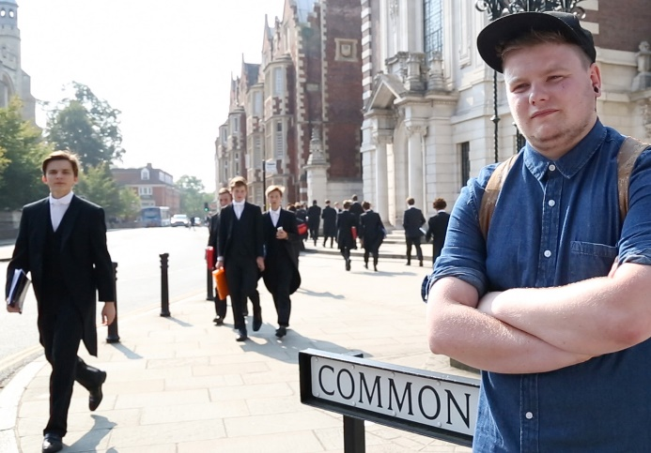
Christopher Eccleston, Julie Hesmondhalgh, Maxine Peake and Samuel West are among those who feature, talking about the barriers for actors from working-class backgrounds.
Distributor: https://theactingclass.info/contact/

Features
A Taste of Honey
Dir: Tony Richardson / UK / 1961 / 12A / 99 mins
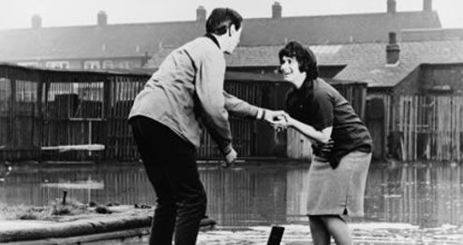
A pregnant teenage girl must fend for herself when her mother remarries, leaving the girl with only a new male friend for support.
Distributor: Janus Films
Format(s): DCP, Bluray, DVD

Ali & Ava
Dir: Clio Barnard / UK / 2021 / 15 / 95 mins
Ali and Ava, both lonely for different reasons, meet and sparks fly. Over a lunar month a deep connection begins to grow, despite the legacy of Ava's past relationship, and Ali's emotional turmoil at the breakdown of his marriage.
Distributor: Altitude Film Entertainment
Format(s): DCP
Access materials: Hard of Hearing subtitles and Audio Description
Babylon
Dir: Franco Rosso / UK / 1980 / 15 / 95 mins
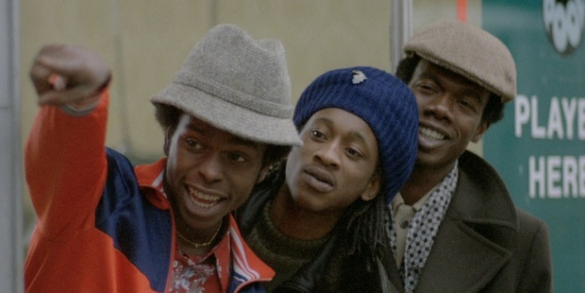
The movie centres around Brindsley Forde's character Blue. He fronts a reggae sound system based in South West London (Brixton). The film captures the trials and tribulations of young black youths in troubled London in the early eighties.

Distributor: Park Circus
Format(s): DCP
Bait
Dir: Mark Jenkin / UK / 2018 / 15 / 89 mins
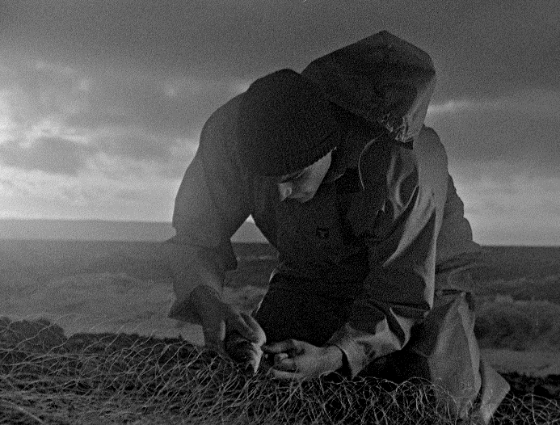
Martin is a fisherman without a boat, his brother Steven having re-purposed it as a tourist tripper. With their childhood home now a get-away for London money, Martin is displaced to the estate above the harbour.

Distributor: BFI Distribution
Format(s): DCP, DVD

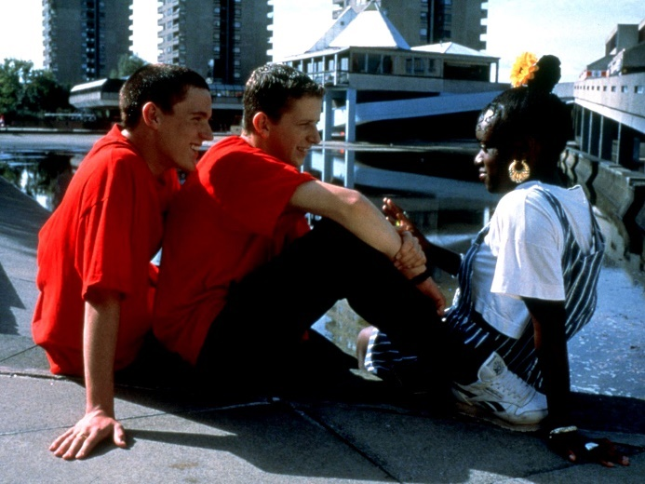
Beautiful Thing
Dir: Hettie Macdonald / UK / 1994 / 15 / 90 mins

Jamie is a shy teenager, often bullied at school. His neighbour Ste has a rough time at home, being beaten by his father and brother. These issues bring them together and they find that what they feel for each other is more than friendship.

Distributor: Park Circus
Format(s): DCP
Bhaji on the Beach
Dir: Gurinder Chadha / UK / 1993 / 15 / 100 mins
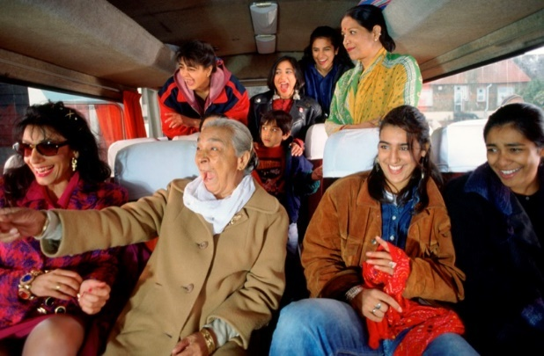
A group of women of Indian descent take a trip together from their home in Birmingham, England to the beach resort of Blackpool. The events of the day lead them to better mutual understanding and solidarity.

Distributor: Park Circus
Format(s): DCP

Billy Elliot
Dir: Stephen Daldry / UK / 2000 / 15 / 110 mins
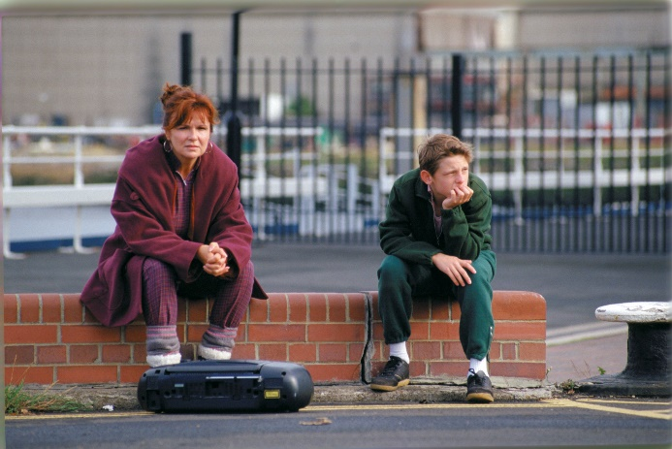
A talented young boy becomes torn between his unexpected love of dance and the disintegration of his family.

Distributor: Park Circus
Format(s): DCP

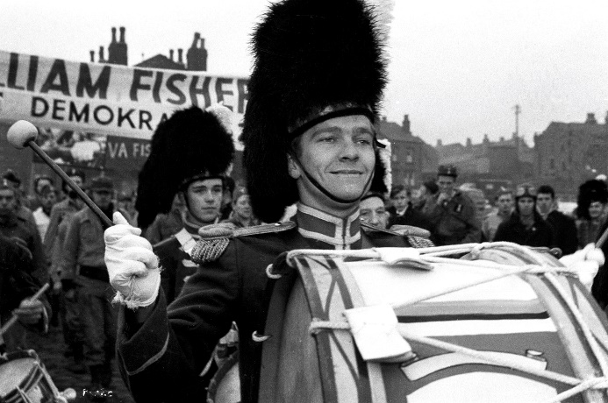
Billy Liar
Dir: John Schlesinger / UK / 1963 / PG / 94 mins
A lazy, irresponsible young clerk lives in his own fantasy world and makes emotionally immature decisions as he alienates friends and family.
Distributor: Park Circus
Format: DCP

Blue Story
Dir: Andrew Onwubolu (Rapman) / UK / 2019 / 15 / 91 mins
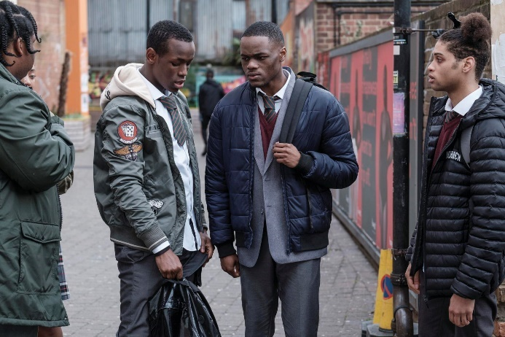
A gang war dooms the lifelong bond of south London friends in this acclaimed crime drama that features its writer-director as a rapping Greek chorus.
Distributor: Paramount Pictures UK

Brassed Off
Dir: Mark Herman / UK / 1996 / 15 / 107 mins
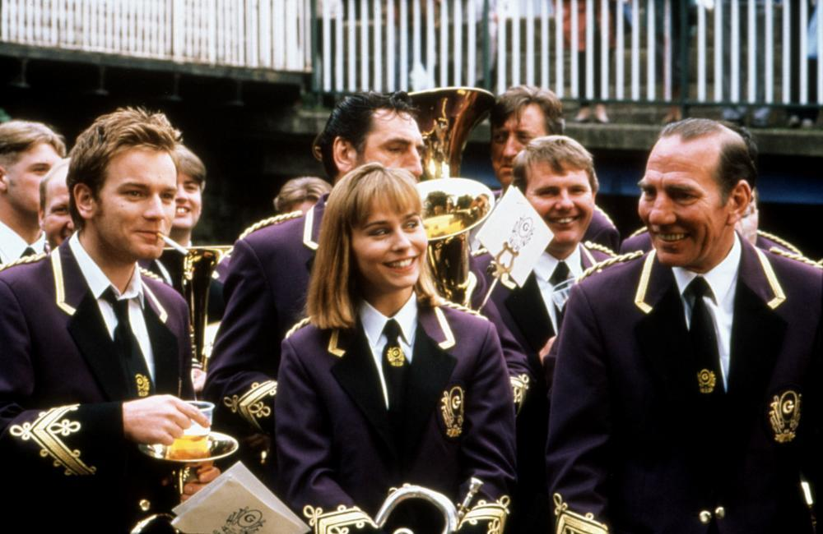
The coal mine in a northern English village may be closing, which would also mean the end of the miners' brass band.

Distributor: Park Circus
Format(s): DCP

Bullet Boy
Dir: Saul Dibb / UK / 2004 / 15 / 87 mins
Ricky, just out of a young offenders’ institute and heading home to Hackney, is determined to go straight. Instead, he heads into trouble when he’s involved in a street clash – siding with his best mate Wisdom against a local gang member.
Distributor: Verve Pictures

Burning an Illusion
Dir: Menelik Shabazz / UK / 1982 / 15 / 105 mins
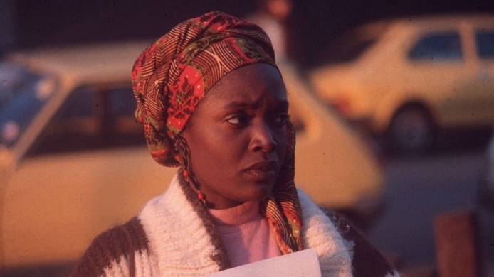
A young black woman in England becomes increasingly frustrated with her life with her lazy, demanding boyfriend, and with the help of friends seeks something better.
Distributor: BFI Distribution
Format(s): DCP, DVD

County Lines
Dir: Henry Blake / UK / 2019 / 15 / 90 mins
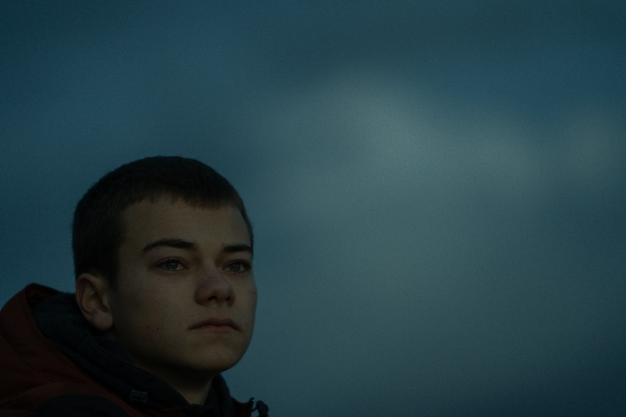
A 14-year-old boy is groomed into a lethal nation-wide drug-selling enterprise which exploits vulnerable children and traffics them across Britain.

Distributor: BFI Distribution
Format(s): DCP, DVD

Everybody’s Talking About Jamie
Dir: Jonathan Butterell, Dan Gillespie Sells, Tom MacRae / UK / 2021 / 12A / 115 mins
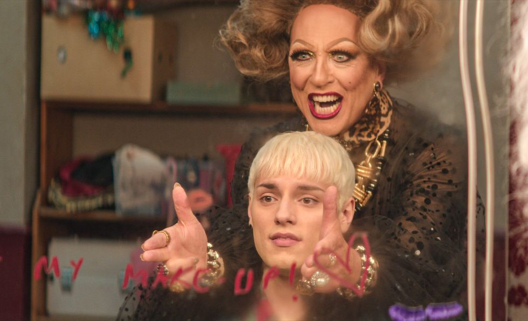
Feature film adaptation of the musical about a teenager from Sheffield, England who wants to be a drag queen.
Distributor: Amazon, Curzon

Fighting With My Family
Dir. Stephen Merchant / UK / 2018 / 12A / 104 mins
A former wrestler and his family make a living performing at small venues around the country while his kids dream of joining World Wrestling Entertainment.
Distributor: Lionsgate/Park Circus
Format(s): DCP

Fish Tank
Dir: Andrea Arnold / UK / 2009 / 15 / 123 minutes
Everything changes for 15-year-old Mia when her mum brings home a new boyfriend.
Distributor: Curzon

God’s Own Country
Dir: Francis Lee / UK / 2017 / 15 / 104 mins
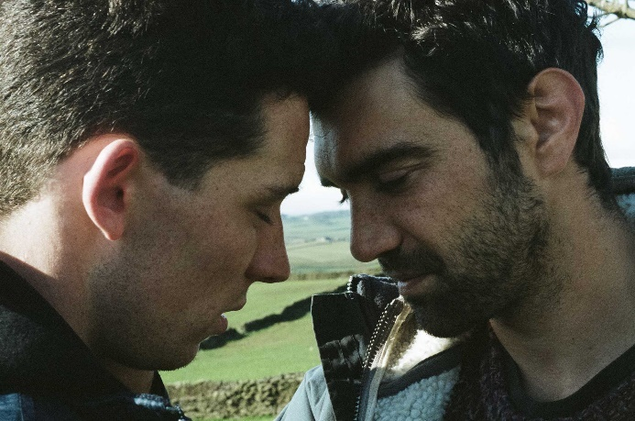
Spring. Yorkshire. Young farmer Johnny Saxby numbs his daily frustrations with binge drinking and casual sex, until the arrival of a Romanian migrant worker for lambing season ignites an intense relationship that sets Johnny on a new path.
Distributor: Picturehouse Entertainment
Format(s): DCP

Kes
Dir: Ken Loach / UK / 1969 / PG / 112 mins
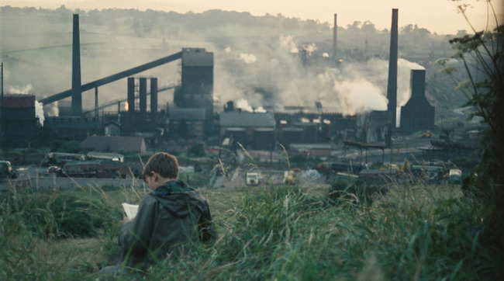
A working-class English boy spends his free time caring for and training his pet kestrel.

Distributor: Park Circus
Format(s): DCP

Lynn & Lucy
Dir: Fyzal Boulifa / UK / 2020 / 15 / 88 mins
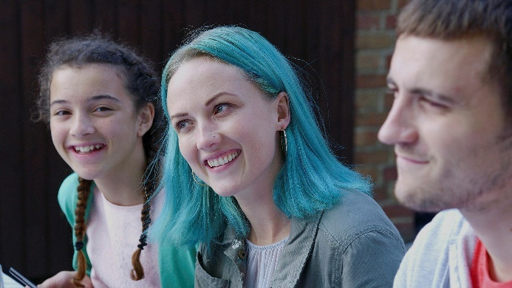
Lynn and Lucy are lifelong best friends, their relationship as intense as any romance. Neither has ventured far from where they grew up. Lynn, who married her first boyfriend and whose daughter is fast growing up, is delighted when the charismatic, volatile Lucy has her first baby boy. Lucy, however, does not react to being a mother as Lynn expects. Soon, they find their friendship is tested in extreme circumstances.
Distributor: BFI Distribution
Format(s): DCP, DVD

Morvern Callar
Dir: Lynne Ramsay / UK / 2002 / 15 / 97 mins
After a tragic loss, a mourning supermarket worker and her best friend hit the road in Scotland, but find that grief is something that you can't run away from forever.

My Beautiful Laundrette
Dir: Stephen Frears / UK / 1985 / 15 / 98 mins
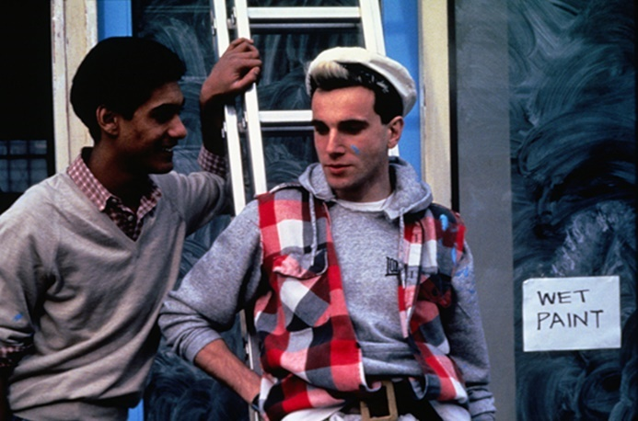
An ambitious Pakistani Briton and his white boyfriend strive for success and hope when they open a glamorous laundromat.

Distributor: Park Circus
Format(s): DCP

My Brother the Devil
Dir: Sally El Hosaini / UK / 2012 / 15 / 109 mins
Two teenage brothers must face their own prejudices head on if they are to survive the perils of being Egyptians growing up on the streets of gangland London.
Distributor: Verve Pictures

Perfect 10
Dir: Eva Riley / UK / 2019 / 15 / 83 mins
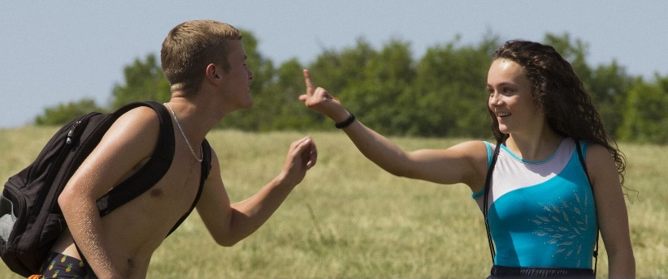
An aspiring teenage gymnast's world is turned upside down with the arrival of the half-brother she never knew she had.
Distributor: 606 Distribution
Format(s):
Audio Description, Subtitles for Deaf and Hard of Hearing

Pin Cushion
Dir: Deborah Haywood / UK / 2017 / 15 / 82 mins

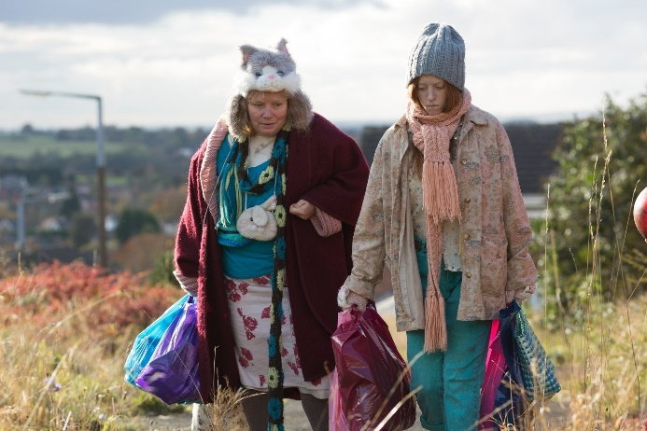
When a socially awkward teen and her outcast mother become targets for the petty and cruel locals in their small town, they seek refuge in an elaborate fantasy world of their own making.

Distributor: Pinpoint
Format(s): DCP

Pressure
Dir: Horace Ové / UK / 1978 / 15 / 121 mins
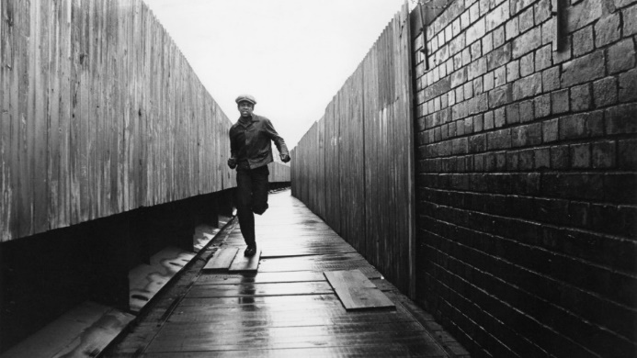
A British-born younger son of an immigrant family from Trinidad finds himself adrift between two cultures.

Distributor: BFI Distribution

Pride
Dir: Matthew Warchus / UK / 2014 / 15 / 120 mins

U.K. gay activists work to help miners during their lengthy strike of the National Union of Mineworkers in the summer of 1984.

Distributor: Park Circus
Format(s): DCP
Access materials: Captions / Audio Description

Ratcatcher
Dir: Lynne Ramsay / UK / 1999 / 15 / 94 mins
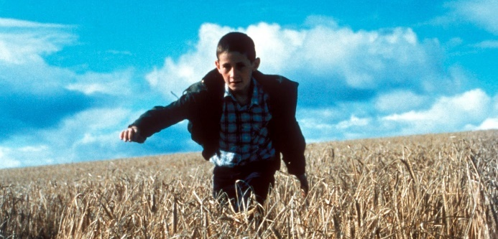
A naïve young lad navigates the dirty squalid streets of 1973 Glasgow and the poor youth around him.

Distributor: Park Circus

Rita, Sue and Bob Too
Dir: Alan Clarke / UK / 1987 / 18 / 93 mins
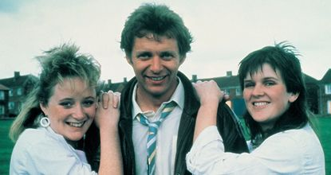
Realistic story of working-class Yorkshire life, alternately serious and light-hearted, as two schoolgirls have a sexual fling with a married man.
Distributor: Park Circus
Format(s): DCP

Rocks
Dir: Sarah Gavron / UK / 2019 / 12A / 93 mins
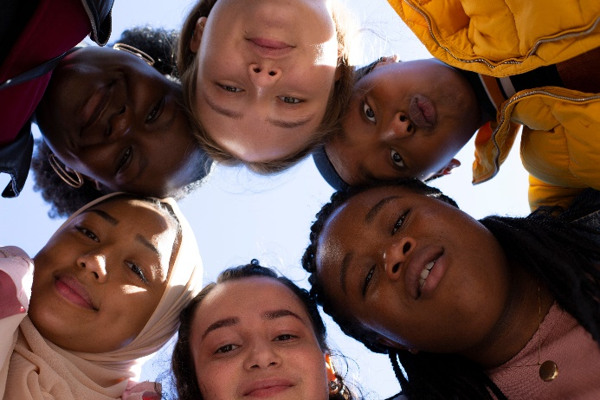
A young teenage girl finds herself struggling to take care of herself and her younger brother after being abandoned by their single mother with no choice but to live out on the streets.

Distributor: Altitude Film Entertainment
Format(s): DCP
Access materials: Hard of Hearing subtitles and Audio Description

Scrubbers
Dir: Mai Zetterling / UK / 1982 / 15 / 93 mins
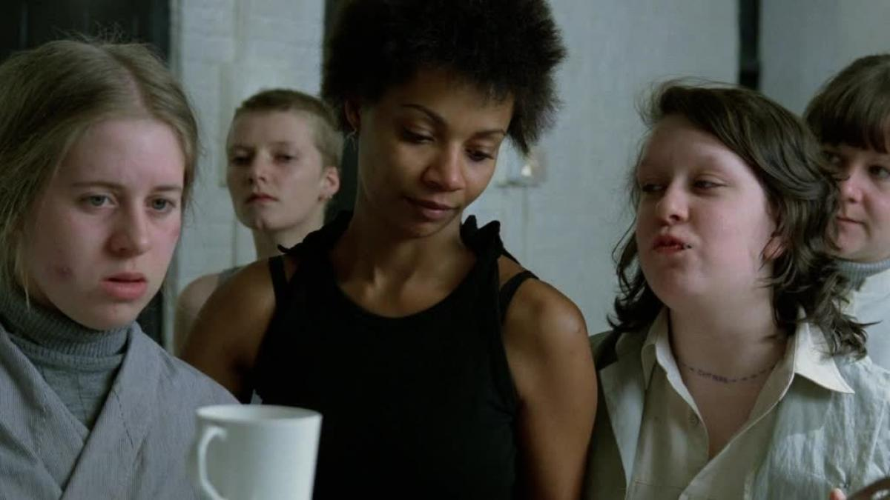

Brutal & funny drama from the writer of Scum about a borstal for girls. Kathy Burke & Miriam Margoyles star in this tale of two women who escape prison for different reasons.

Distributor: Handmade Films
Format(s):
Access materials: Descriptive Subtitles
Second Coming
Dir: debbie tucker green / UK / 2014 / 15 / 105 mins
What if an immaculate conception took place in a South London household? Idris Elba stars in a subtle, thought-provoking and original family drama.

Distributor: Kaleidoscope Entertainment

Secrets & Lies
Dir: Mike Leigh / UK / 1996 / 15 / 142 mins

Following the death of her adoptive parents, a successful young black optometrist establishes contact with her biological mother -- a lonely white factory worker living in poverty in East London.

Distributor: Janus Films
Format(s): DCP, Bluray

Somers Town
Dir: Shane Meadows / UK / 2008 / 12A / 71 mins
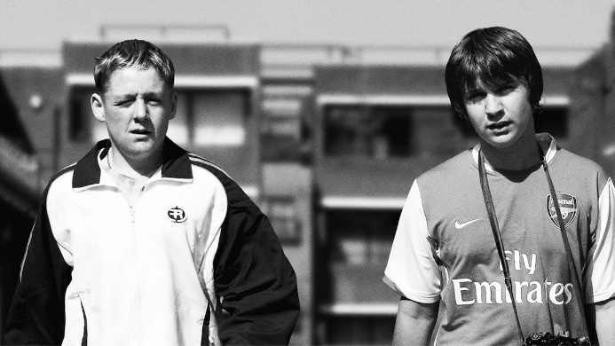
A black-and-white study of a social environment in London, concentrating on a pair of unlikely new friends and the girl they both fancy.

Distributor: Park Circus

Sparrows Can’t Sing
Dir: Joan Littlewood / UK / 1963 / PG / 94 mins
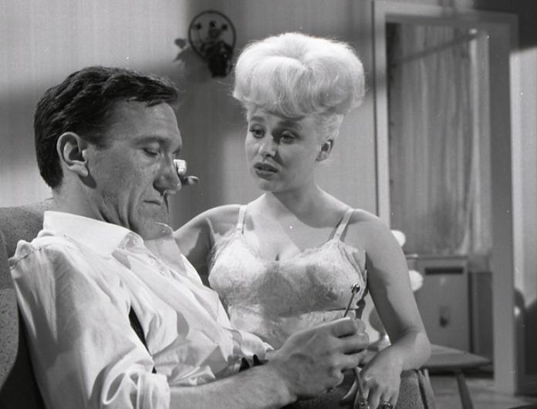
The late, great Barbara Windsor stars in this 60s classic. Charlie returns to the East End after two years at sea to find his house demolished and wife Maggie gone

Distributor: Park Circus
Format(s): DCP

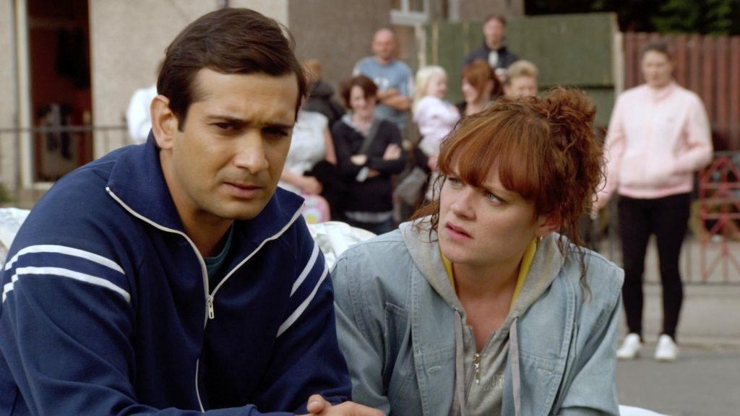
The Arbor
Dir: Clio Barnard / UK / 2010 / 15 / 92 mins

The true story of troubled British playwright Andrea Dunbar who died aged 29, leaving a legacy of three plays and a daughter, Lorraine. She wrote about the difficult life she endured growing up in England’s Bradford housing projects.

Distributor: Verve Pictures

The Full Monty
Dir: Peter Cattaneo / UK / 1997 / 15 / 91 mins
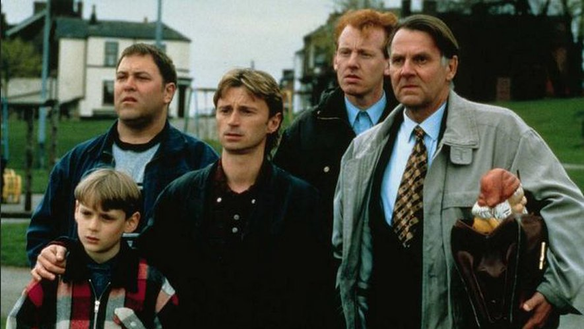
Six unemployed steelworkers from Sheffield form a male striptease act. The women cheer them on to go for "the full monty" - total nudity.

Distributor: Park Circus

The Goob
Dir: Guy Myhill / UK / 2014 / 18 / 85 mins

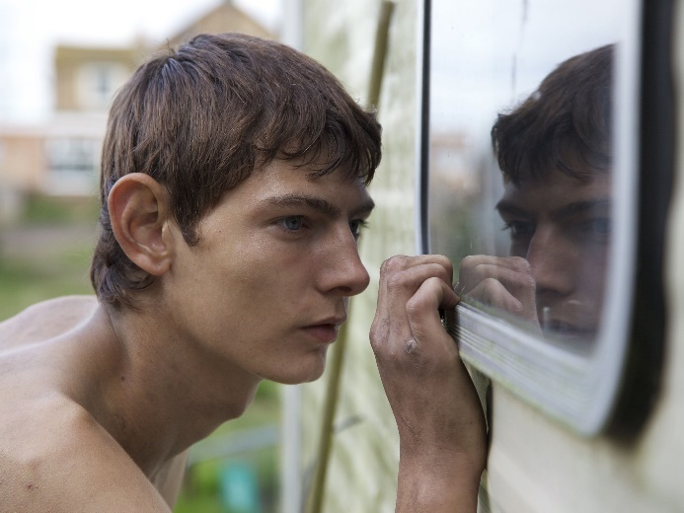
A long hot summer in rural Norfolk and a rough coming of age for Goob Taylor, fighting with brutal, womanising stock car racer Gene Womack for his mother's attention, and falling for the exotic charms of a field worker.

Distributor: Thunderbird Releasing

The Last Tree
Dir: Shola Amoo / UK / 2019 / 15 / 99 mins

After a happy childhood in the countryside, a teenager moves to London, where he must navigate an unfamiliar environment on his road to adulthood.

Distributor: Picturehouse Entertainment
Format(s): DCP

The Loneliness of the Long Distance Runner
Dir: Tony Richardson / UK / 1962 / 12A / 103 mins
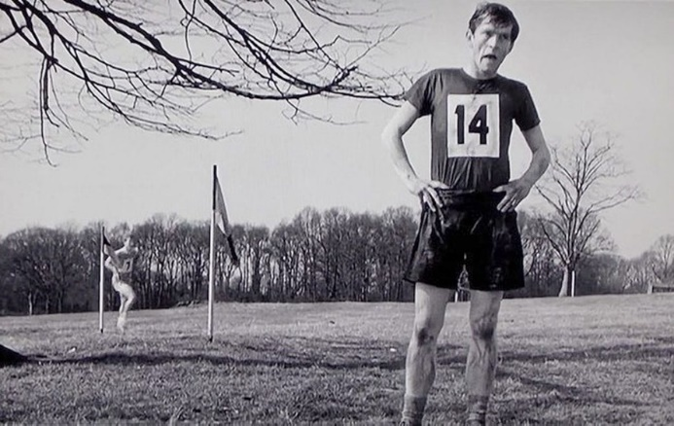
A young thief takes up long-distance running when he is sent to a borstal.

Distributor: Park Circus
Format(s): DCP

The Old Dark House
Dir: James Whale / UK / 1932 / PG / 75 mins

Seeking shelter from a storm, five travellers are in for a bizarre and terrifying night when they stumble upon the Femm family estate.

Distributor: Park Circus
Format(s): 4k DCP

Under the Skin
Dir: Carine Adler / UK / 1997 / 18 / 83 mins

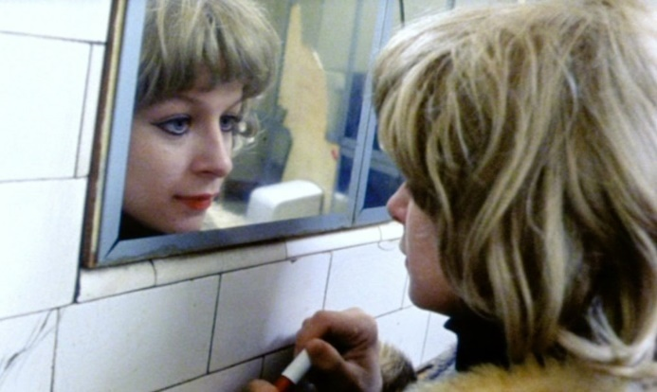
A woman explores her sexuality to cope with the passing of her mother, leading her to profound revelations about herself and the people closest to her.

Distributor: BFI Distribution
Format(s): 35mm, DVD

Young Soul Rebels
Dir: Isaac Julien / UK / 1991 / 18 / 105 mins
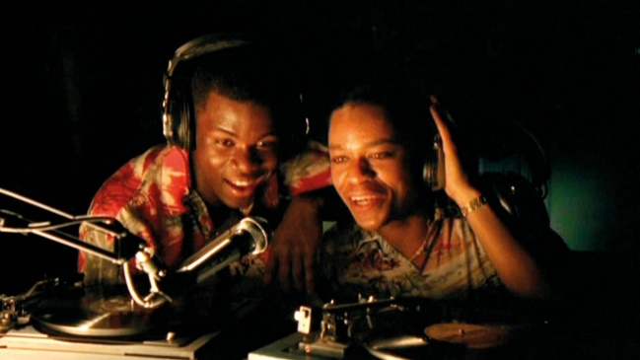
Youth culture meets identity politics in this part-thriller, part-gay love story set in London in 1977. Days before the Queen's Silver Jubilee celebrations, the hedonistic world of pirate radio DJs Chris and Caz is shattered when a close friend is killed while cruising in the local park. The black community think it’s the National Front, but the police pull Chris in as a suspect.

Distributor: BFI Distribution
Format(s): 35mm, DVD

International Working-Class Stories & Creatives

A mix of features, documentary and short film.
American Honey
Dir: Andrea Arnold / UK, USA / 2016 / 15 / 163 mins
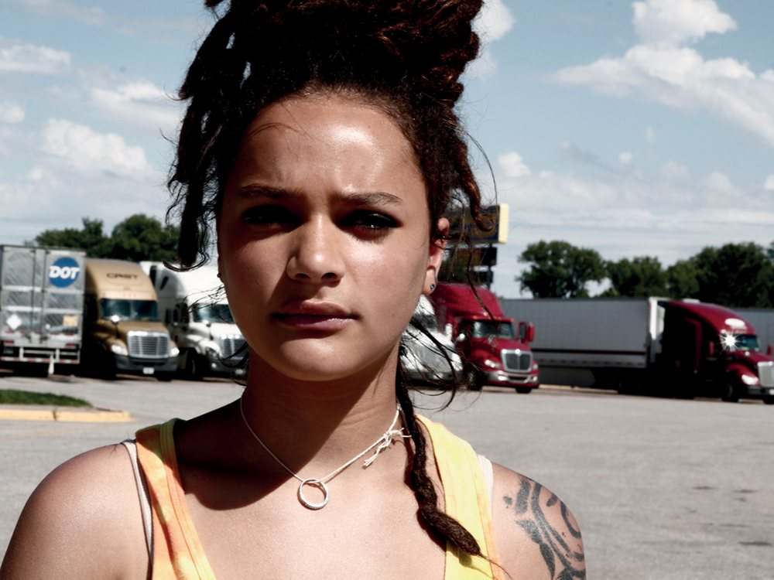
A teenage girl with nothing to lose joins a traveling magazine sales crew, and gets caught up in a whirlwind of hard partying, law bending and young love as she criss-crosses the Midwest with a band of misfits.

Distributor: Park Circus
Format(s): DCP

Be Seeing You
Dir: Chris Marker / France / 1967 / 38 mins
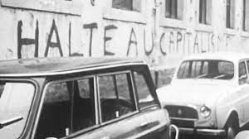
At the Rhodiaceta textile factory in Besançon, France, the workers in the labor union CGT are on strike. The film is made up of extended monologues and interviews with the strike organizers and workers, who talk at length about the worker's culture and the power of the labor force.

Distributor: Iskra Films
Format(s): 16mm, Bluray, DCP

Bicycle Thieves ( Ladri di biciclette)
Dir:Vittorio De SIca / Italy / 1948 / U / 89 mins
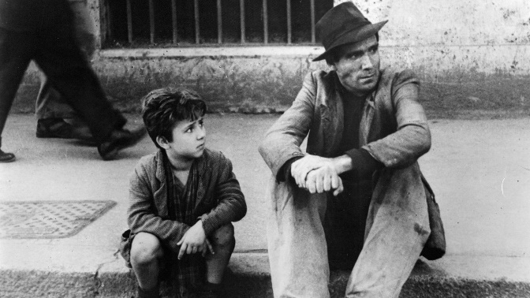
In post-war Italy, a working-class man's bicycle is stolen, endangering his efforts to find work. He and his son set out to find it.

Distributor: Janus Films
Format(s): DCP, Bluray, DVD
Access materials: English language subtitles

Black Girl (La noire de...)
Dir: Ousmane Sembène / Senegal, France / 1965 / 15 / 60 mins
A Senegalese woman is eager to find a better life abroad. She takes a job as a governess for a French family, but finds her duties reduced to those of a maid after the family moves to the south of France. In her new country, she is constantly made aware of her race and mistreated by her employers.

Distributor: Janus Films
Format(s): DCP, Bluray
Access materials: English language subtitles

Born in Flames
Dir: Lizzie Borden / USA / 1983 / 15 / 90 mins

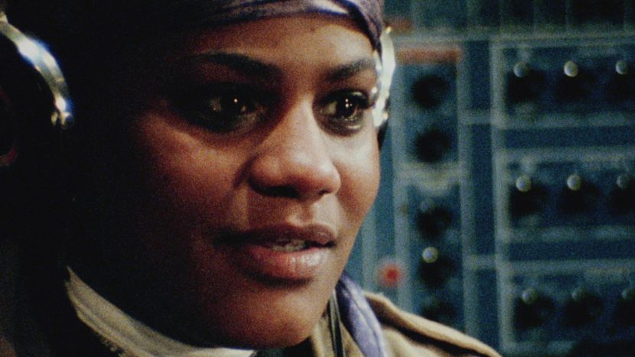
Set ten years after the most peaceful revolution in United States history, it presents a dystopia in which the issues of many groups - minorities, liberals, gay rights organisations, feminists - are dealt with by the government.

Distributor: Cinenova

Daughters of the Dust
Dir: Julie Dash / USA / 1991 / 12A / 112 mins
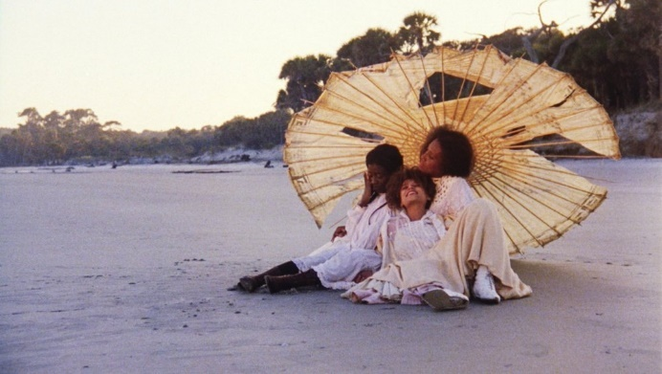
At the dawn of the 20th century, a multi-generational family in the Gullah community on the Sea Islands off of South Carolina struggle to maintain their cultural heritage and folklore while contemplating a migration to the mainland, even further from their roots.

Distributor: BFI Distribution
Format(s): DCP

Everlasting Moments (Maria Larssons eviga ögonblick)
Dir: Jan Troell / Sweden / 2008 / 15 / 111 mins
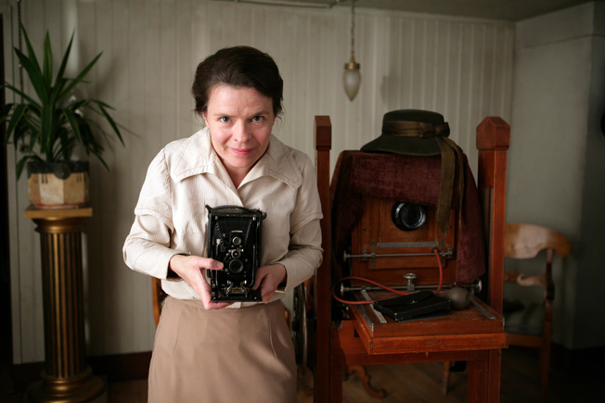
In a time of social change and unrest, war and poverty, a young working class woman, Maria, wins a camera in a lottery. The decision to keep it alters her whole life.

Distributor: Park Circus
Access materials: English language subtitles

Faces Places (Visages villages)
Dir: Agnès Varda, J.R. / France / 2017 / 12A / 92 mins

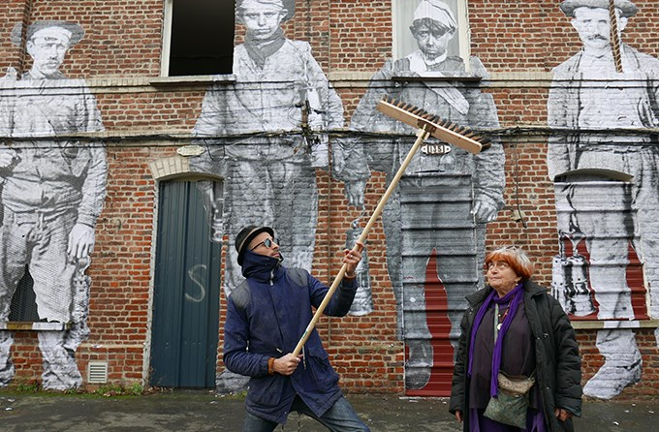
Director Agnès Varda and photographer/muralist J.R. journey through rural France and form an unlikely friendship.

Distributor: Curzon
Format: DCP
Access materials: English language subtitles

Framing Agnes
Dir: Chase Joynt / Canada, USA / 2002 / 75 mins
FRAMING AGNES turns the talk show format inside out in response to the media's ongoing fascination with trans people. The film breathes life into six previously unknown stories from the archives of the UCLA Gender Clinic in the 1950s.
Distributor: The Film Collaborative (enquire for festivals) jeffrey@thefilmcollaborative.org

Girlhood ( Bande de filles)
Dir: Céline Sciamma / France / 2014 / 15 / 113 mins

A girl with few real prospects joins a gang, reinventing herself and gaining a sense of self confidence in the process. However, she soon finds that this new life does not necessarily make her any happier.

Distributor: Park Circus
Format(s): DCP
Access materials: English language subtitles

Ikiru
Dir: Akira Kurosawa / Japan / 1952 / PG / 141 mins

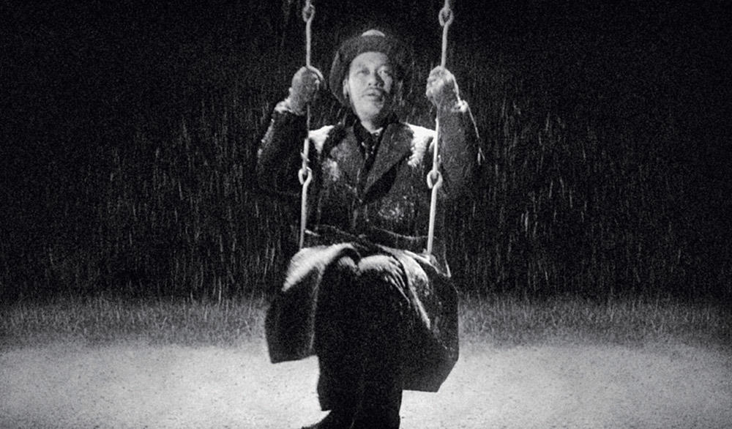
After learning that his stomach cancer has left him with less than a year to live, a Tokyo bureaucrat struggles to reconcile with his impending death and begins looking for ways to make his remaining days meaningful.

Distributor: BFI Distribution
Format(s): 35mm, DVD
Access materials: English language subtitles
La haine
Dir: Mathieu Kassovitz / France / 1995 / 18 / 98 mins

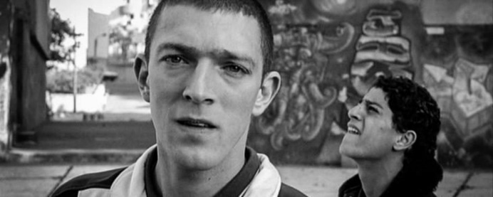
24 hours in the lives of three young men in the French suburbs the day after a violent riot.

Distributor: BFI Distribution
Format(s): DCP, DVD
Access materials: English language subtitles

Moonlight
Dir: Barry Jenkins / USA / 2016 / 15 / 111 mins
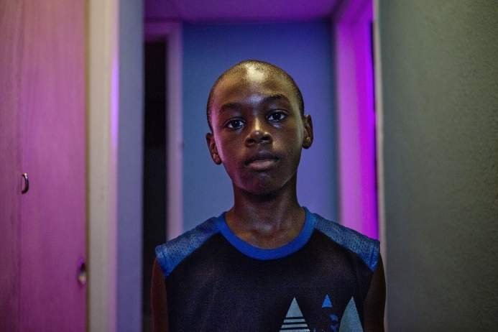
A young African-American man grapples with his identity and sexuality while experiencing the everyday struggles of childhood, adolescence, and burgeoning adulthood.

Distributor: Altitude Film Entertainment

Parasite (Gisaengchung)
Dir: Bong Joon-ho / South Korea / 2019 / 15 / 132 mins

Greed and class discrimination threaten the newly formed symbiotic relationship between the wealthy Park family and the destitute Kim clan.

Distributor: Curzon Film
Access materials: English language subtitles

Pather Panchali
Dir: Satyajit Ray / India / 1955 / U / 111 mins

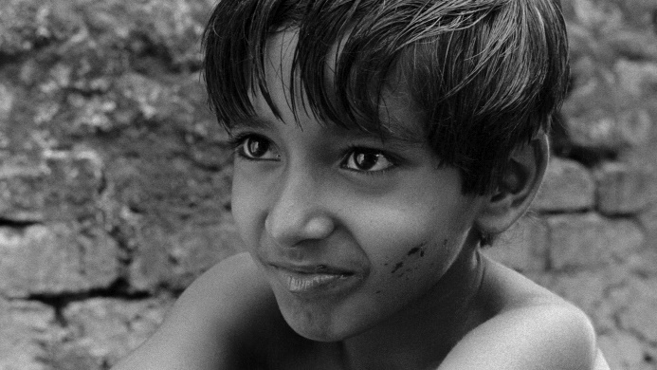
Apu and his family live in a village where they try to make ends meet. The father leaves for the city to try and earn more money while his daughter dies of a fever which prompts the family to move.

Distributor: Janus Films
Format(s): DCP, Bluray
Access materials: English language subtitles

Samson and Delilah
Dir: Warrick Thornton / Australia / 2009 / 15

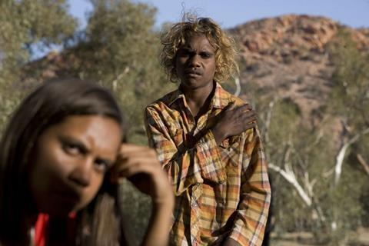
Samson, a cheeky 15-year-old boy, and Delilah, live in an isolated Aboriginal community in the Central Australian desert. The two teenagers soon discover that life outside the community can be cruel. Lost, unwanted and alone they discover that life isn’t always fair, but love never judges.
Distributor: Trinity Films

Shadows in Paradise (Varjoja paratiisissa)
Dir: Aki Kaurismäki / Finland / 1986 / 74 mins

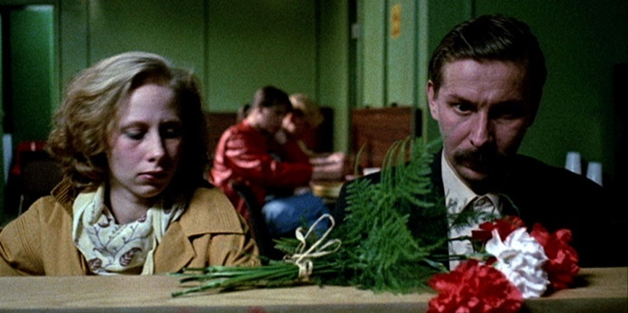
An episode in the life of Nikander, a garbage man, involving the death of a coworker, a love affair and much more.

Socrates
Dir: Alexandre Moratto / Brazil / 2018 / 15 / 71 mins

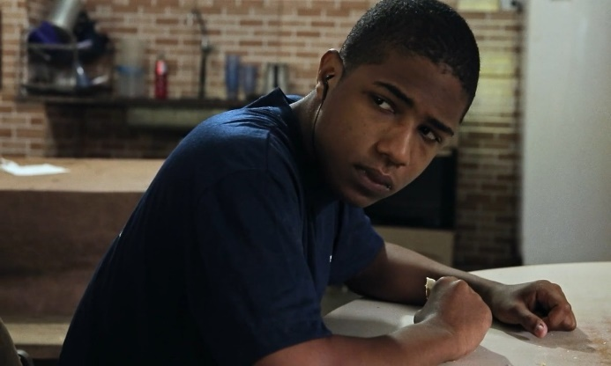
After his mother's sudden death, Socrates, a 15-year-old living on the margins of São Paulo's coast, must survive on his own while coming to terms with his grief.

Distributor: Peccadillo Pictures
Format(s): English language subtitles

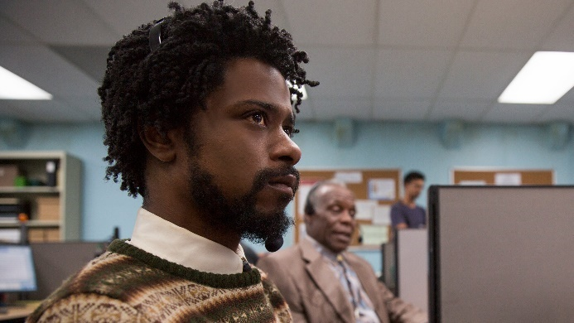
Sorry to Bother You
Dir: Boots Riley / USA / 2018 / 15 / 112 mins
In an alternate present-day version of Oakland, telemarketer Cassius Green discovers a magical key to professional success, propelling him into a universe of greed.

Distributor: Park Circus
Format(s): DCP
Access materials: Captions / Audio Description

Tangerine
Dir: Sean Baker / USA / 2015 / 15 / 88 mins

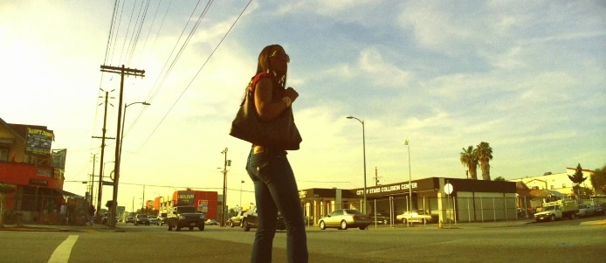
On Christmas Eve, transgender sex worker Sin-Dee Rella meets her friend and fellow transgender sex worker Alexandra at Donut Time. Once informed that her boyfriend and pimp, Chester, has been cheating on her with a white cisgender woman, Sin-Dee storms out to search the neighbourhood.

Distributor: Park Circus
Format(s): DCP

Two Days. One Night (Deux jours, une nuit)
Dir: Jean-Pierre Dardenne, Luc Dardenne / Belgium, France, Italy / 2014 / 15 / 92 mins
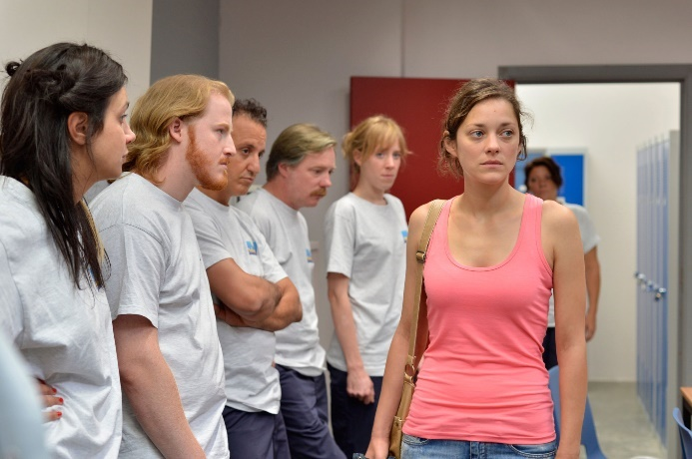
Liège, Belgium. Sandra is a factory worker who discovers that her workmates have opted for a 1,000 euro bonus in exchange for her dismissal. She has only a weekend to convince her colleagues to give up their bonuses in order to keep her job.

Distributor: Curzon Film
Access formats: English language subtitles

Winter’s Bone
Dir: Debra Granik / USA / 2010 / 15 / 96 mins
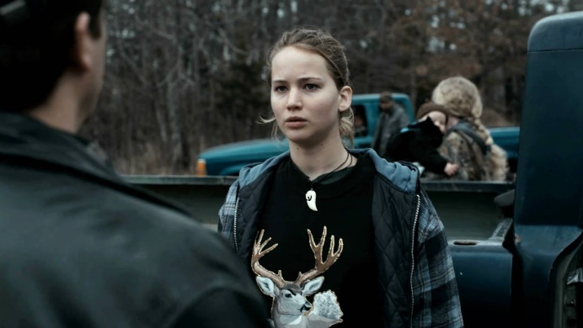
An unflinching Ozark Mountain girl hacks through dangerous social terrain as she hunts down her drug-dealing father while trying to keep her family intact.

Distributor: Curzon Film

