\

[TLC logo / T+OS logo]

How to Podcast Your Live Event

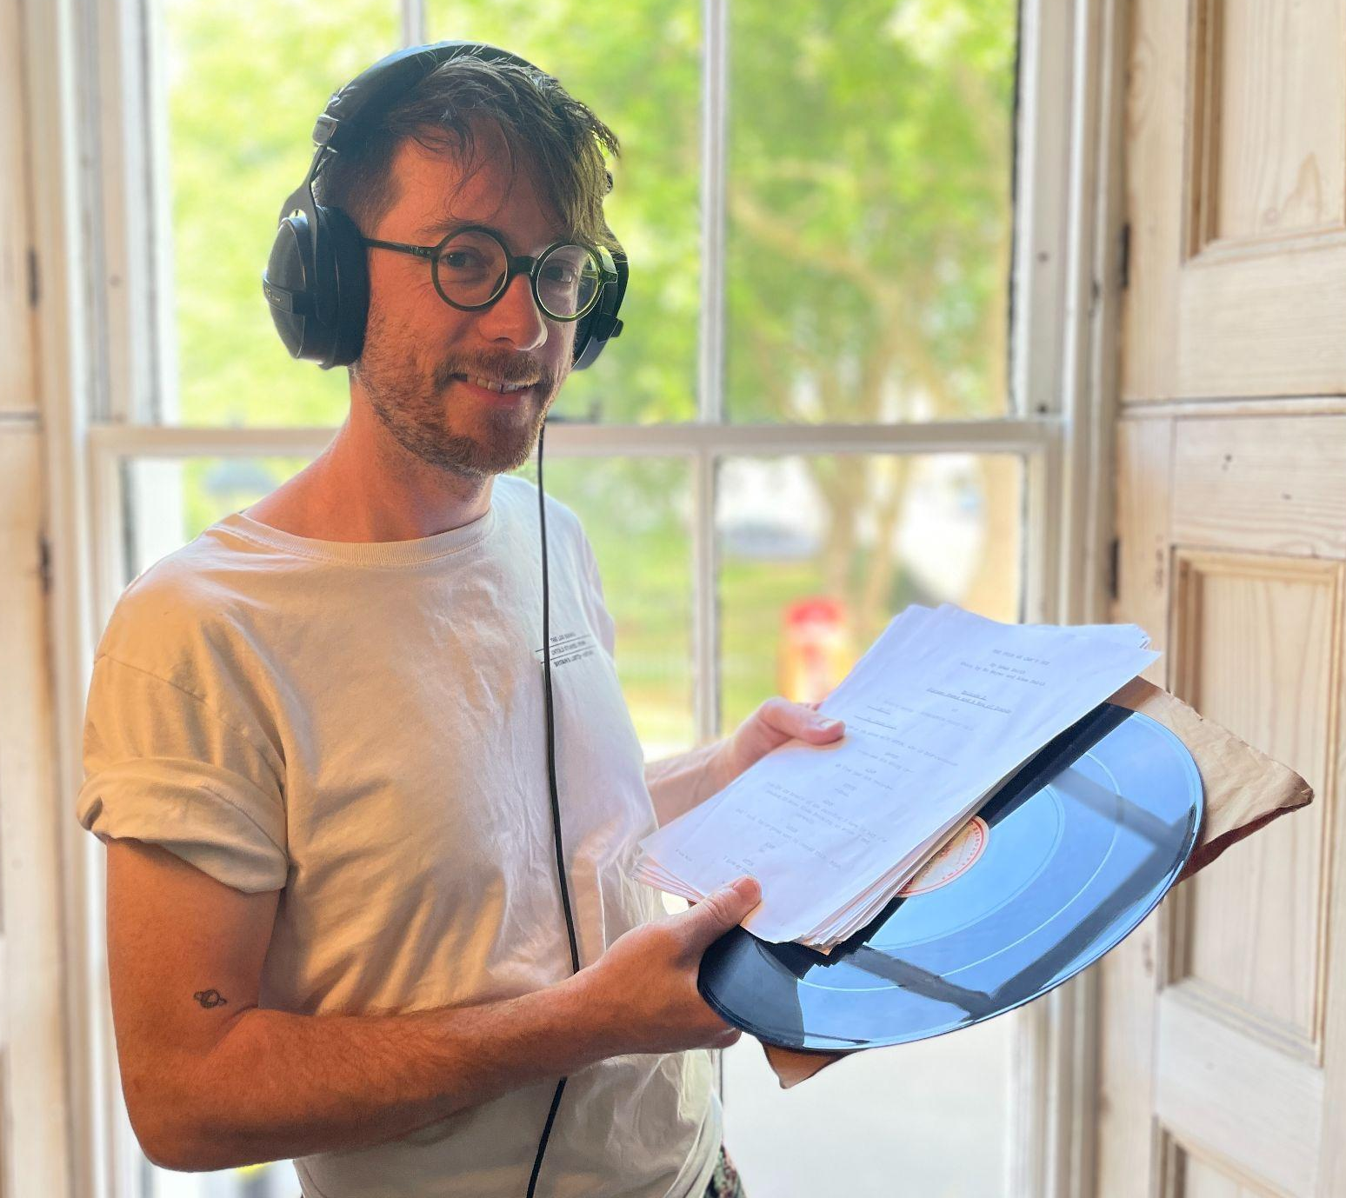
Adam Zmith
Co-founder of Aunt Nell
Producer of The Log Books
and The Film We Can’t See
adam@adamzmith.com

About this guide
Hello, this document is for film programmers / event managers / tech people working in cinemas who want to make a podcast out of their live events. This guide intends to give you broad headings for everything you need to think about, some answers for how to make it all happen, and links out to more. This guide assumes that your event takes place in a cinema with a PA/sound system and a tech person. I’ve used standard terms so that you can throw your deeper questions at Google using the right words. Some words are in bold and defined in the glossary at the end. I hope it helps! It’s great that you’re thinking about how to get your valuable events to more people through the power of audio. Best of luck 🤗

THE BASICS

What is a podcast?
A ‘podcast’ is essentially a convenient way to share episodes of audio online. You upload your audio to a host platform and pay them to store it and help you to distribute it. The host platform makes the audio into an RSS feed ready for distribution (RSS stands for Really Simple Syndication, and an RSS feed looks like a link). This RSS carries the audio to the countless directories or apps, which is where audiences actually finally listen to the audio, such as Apple Podcasts (standard on iPhone), Google Podcasts (standard on Android phones) or Spotify. These apps are a shopfront for lots of podcasts from different sources, so they are built to help the user find the right podcast for them.

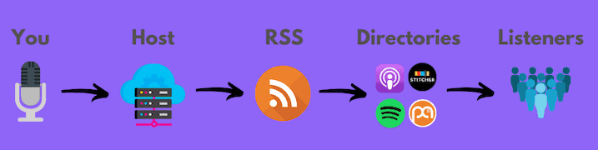

Some podcasts are not available for free, and so they stay only inside the apps of the companies that make them (eg, some BBC podcasts on BBC Sounds, and Audible content from Amazon).

There’s no set length for a podcast episode or a series. Some podcasts have episodes of 10-15 mins, some have episodes that are more than 2 hours, and some have a mix of lengths. Some podcasts are three-episode series, some publish a new episode every single week for years. As with anything, you should really make it the length it needs to be. (But this doesn’t mean it should be long just because it can be!)

Think of a podcast like a monthly magazine: when you launch it, you’re expecting to publish under the same title regularly or for a set number of issues. In contrast, a single audio recording of an interview or event is more like a book, or just a one-off, and can be hosted on an audio sharing platform, like Soundcloud, without distribution to podcast directories/apps.

So you might want to start a podcast feed, making the work available through the podcast apps, and publish new episodes regularly. That’s what this guide focuses on. Or you might want to make a recording of an event available online on Soundcloud or your website.

What’s your goal?
Before you do anything, write down what you want to achieve. Eg:
- We want to open up our physical events to those who can’t be there — focus on accessibility
- We want people who are searching for audio content to find us — who exactly?
- We want to reach film fans; or we want to reach beyond film fans
- We want to create a successful podcast that gets sponsored by a brand — how exactly will you do this?

What do I need to set up a podcast feed?
- Podcast name: make it catchy, distinctive and easy to search for
- Cover art: 3000 x 3000 pixels, 72 dpi, jpg or png, best not to include a mic in the pic, more tips here
- Host: an account with Acast, Podbean, Buzzsprout or Libsyn — you’ll probably need to pay because they’re storing your audio and distributing it for you, and they also usually include a website for your podcast
- Distribution: check what your host does automatically, then check if you need to ‘submit my RSS feed’ to a few big apps such as Spotify and Google
- Episode audio files: with a title and description text for each episode

RECORDING

Equipment
- Recording device:
  - Zoom recorders are the best: eg, the H4n Pro handy recorder gives you lots of recording options and mic inputs, or the cheaper H2n Recorder
  - You can plug the H4n and some other Zooms into the PA system using a standard XLR cable
  - Your phone! The voice memo app in your phone is a good basic recorder if you need to grab an unexpected interview with someone
  - Your computer! Some software enables you to record directly onto a computer, but it might be tricky connecting a venue sound system to it
- Mics:
  - Your recording device may have an in-built mic, but you may want more flexibility or quality by using a handheld mic or one on a stand
  - Most cinemas have a PA system fed by mics for events — best to use these if the room and the tech are already set up for them
  - The Marantz MPM 1000 is a good cardioid mic, which means it’s good for interviews/talks so it focuses on picking up the panellist’s voice if positioned right
- Mic stand(s)
  - You might need these for live events — if you can trust the panellist to sit still, using a stand is better than relying on them to hold the mic at the right distance from their mouths for an hour, and is more comfortable for them
- Headphones
  - Any headphones that sit over the ear are best, better than earbuds, so they block out as much noise as possible so you can listen to what the mic is actually picking up, eg Bose 700 (super expensive! You can definitely use cheaper ones fine)
- Memory
  - Most recorders use SD cards — make sure you’ve always got a few spare, with free capacity
- Power
  - For an event recording or sit-down interview, it’s best to plug the recorder into power (eg, Zoom H4n just uses a standard mini jack power)
  - Most recorders can run on standard AA batteries too, giving you more flexibility to walk around with it — make sure you have enough as they do guzzle power

You can buy all of these things online from the major shops and indie audio/music shops. Gear4Music offers lots of podcast equipment bundles.

People
To record a live event, make sure it’s one person’s job to manage all the tech. This shouldn’t be a panellist or chair person. Ideally it’d be a tech person who is familiar with the venue and can use the existing tech equipment, adding on anything they need such as a recorder. If you’re looking for someone, you may find these words or titles useful: audio engineer, sound recording engineer, live podcast producer, tech assistant, tech producer.

Recording tips
- Allow plenty of time to check the space, the panellists’ voices, your equipment and things like power cables/batteries and memory capacity
- Ask all panellists if they are comfortable being recorded, inform them of exactly how you plan to use the recording, explain how they need to hold their mic if necessary, and ask them not to speak over each other
- Use headphones on the recording device so you can hear what it is actually picking up, and if it sounds crap just adjust the mic, move rooms, change positions, add more soft things, and so on
- Position the mic so it’s not scraping against anything, eg lapel mics rub against necklaces and hair
- Position the mic depending on what kind of mic it is — eg, a ‘cardioid’ mic has a ‘front’ or ‘top’ that the panellist should speak into
- Position the mic close to the panellist’s mouth, but not so close that it distorts — you’ll have to listen to the levels and adjust accordingly. If a panellist is holding their own mic, someone will have to watch that they don’t wave it around or forget to hold it up
- Record in WAV file format for the highest quality.

What’s the best location for recording an intimate conversation?
A cinema is soundproofed and fairly soft: great location. Otherwise record in a studio such as these in London: Content is Queen or The Glasshouse. Or a place where the interviewees/panellists are comfortable, such as their home. Some rooms can be a good substitute for a studio, but here are some tips on choosing one and making it sound good:
- Pick a room with soft things, such as curtains and sofas; avoid rooms with hard surfaces like offices and kitchens
- If you’re recording at a table or desk, place a blanket over it then your equipment on top
- The aim of these soft surfaces is to absorb the excess sound so it doesn’t bounce around the room and enter the mic as an echo
- Pick a quiet room: no bustle just the other side of the door; no overhead or underground trains; and turn off the fridge or AC unit if it’s humming
- Make sure no one is going to disturb you: close the door, turn off all phones, give yourself the time to have the conversation you want

What’s the best way to record at a live event?
If you want to record a live event, mic the panellists separately with little mics on their lapels or handhelds or mics on stands. Don’t settle for a single mic three metres away from all the panellists, because their voices will be faint and often drowned by the sounds of the room. You can place an additional mic in the audience to capture the audience noises (more on mixing these different recordings later).

If you want to record on the fly, such as vox pops at a networking event, use a handheld recorder (see Equipment, above). Consider taking the interviewee to a quieter corner and/or placing your back to the room: this will block some background noise but still capture the general ambience of being at an event.

What’s the best setup for recording a live panel talk?
- A mic for every panellist, close to their mouths. One mic won’t ‘pick up everyone’
- Ideally record a different track for every panellist (giving you options in editing, to adjust their levels to make them sit relative to each other) - the Zoom H4n has this multitrack function
- Mics should go into the PA system in the venue for amplification at the venue for the live audience to hear
- Use the output on the PA system to feed an external recorder such as a Zoom H4n
- If you are amplifying the voices in the room through the PA, don’t just ‘record the room’ for the podcast, ie using a mic to record what’s coming out of the speakers in the room — the voices will be too quiet and distorted
- BUT you should record a track that is just the room - preferably on a second recording device or your phone - so you have an audience track capturing things like laughter and applause, and set how loud you want this in the eventual mix
- Important! If you’re recording more than one track, you need to do a ‘sync clap’ at the beginning: ask everyone with a mic to countdown from 3 and then do a single clap near their mic — this will show up as a spike on each track in the audio when you come to edit it, so you can move these spikes close to each other so that the tracks are synced

Here’s a standard set-up for a recording of a live event:
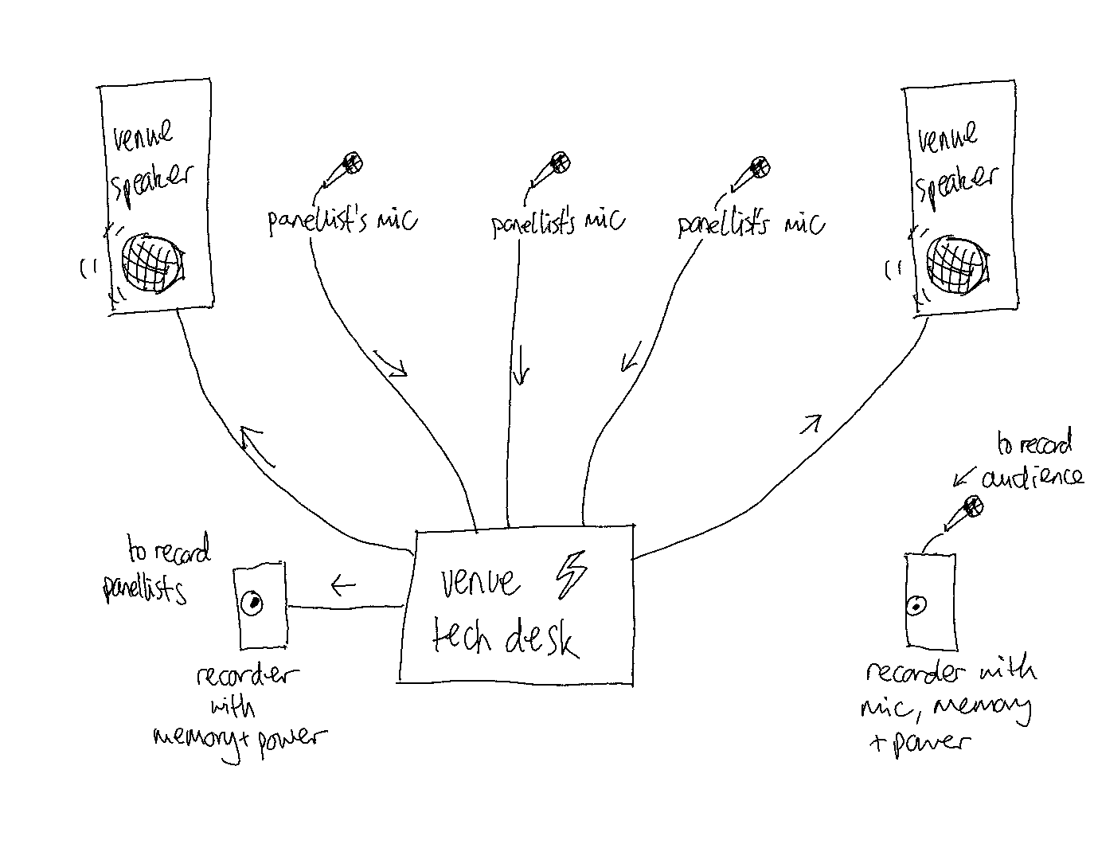

EDITING AND MIXING
Things to consider:
- Yes, you’ll have to do some work on the recording! You may want to cut out certain parts of the interview/talk, or improve the sound clarity, and you’ll definitely want to add an intro and outro so the listener isn’t dropped straight in
- Some editing software options: Adobe Audition (paid) or GarageBand or Audacity (free)
- The number of separate tracks you have will dictate how much flexibility you have, eg, if you have one track for each panellist, you can adjust their levels to bring louder and softer voices closer together to make it easier on the listener
- Record a standard intro, preferably with a succinct line about what the podcast is about, who you are, and what’s happening; and a standard outro with calls to email, subscribe, rate and review — and add these at the start and end of the audio recording, or using your host platform’s intro/outro functions if it has them
- Add a little music for texture and/or to signal transitions between sections. If you use a musician’s music without permission, even a tiny clip, you’re ripping them off. Here are some good royalty-free options
- You probably want to add some basic ‘compression’ to make the audio sound more even (so there’s less variation between the loud and quiet parts, which can be jarring). Best to search on YouTube for a video on how to use compression on the editing software you’re using
- If you recorded in WAV file format, edit in that too. Then when you export the final audio file, you can export in mp3 file format and upload this to your host

ACCESSIBILITY
Here are some things that will increase the accessibility of your podcast:
- Make clear audio recordings (see Recording section, above)
- Include a BSL interpreter at the live event, and make sure they’re thanked by a panellist at the event, so their presence is included on the recording
- Audio-describe any images or videos shown at the live event
- Consider contrast and text sizes in your cover art design: more info here
- Build a website. You can embed the podcast using the embed code from your host platform, so people can listen directly on your website (although be aware that the majority of people listen to podcasts in their podcast apps). The website can also host related content, such as images (with audio descriptions), extra resources, and transcripts. Make sure the website follows these standards on accessibility
- Publish transcripts. You could use software such as Trint or Otter.ai to transcribe your episodes, then you should correct it yourself as the software isn’t fully accurate. Publish the transcripts on the website as text and in a downloadable PDF. Link to the webpage containing these transcripts in the podcast episode description text — this is so that a person using a podcast app can click through to the transcript. You could also advertise the transcript in the episode intro audio
- Make sure your social media posts about the podcast are accessible: eg, subtitles on videos, alt-text on images. More on this here

PUBLISHING AND PROMOTING
- If you have an account with a host, and you’ve uploaded your episodes there (audio files, episode title and description text, artwork, etc), you’ll have an RSS feed which will be distributed to different directories, or listening apps — this may take 24 hours though
- You only pay the host, because they’re storing your audio; not the directories/listening apps like Spotify or Apple Podcasts, which are just accessing the audio on behalf of the listener
- Most hosts have good tools that help you to promote the podcast too, eg Acast has a function allowing you to make clips from the podcast and download them as videos that you can share on social media
- Promote every episode on your social media channels and newsletters, and ask partners and panellists to do the same

SUCCESS
- Podcast analytics are notoriously bad — no one really agrees on what a ‘listen’ is, whether downloads are more valuable, what is a good audience size, and so on.
- Remember if you publish regularly, each episode has a different start date, and since it takes time for each episode to accumulate listens, you can only compare two episodes based on their separate ‘first month’ numbers
- Ask your listeners to give you feedback — call out for it in the podcast, eg “Leave a review on Apple Podcasts” or “Rate and review this podcast wherever you listen” — and use this to gauge your level of success
- Compare whatever you discover with the goal you set at the beginning

GLOSSARY

Word | Meaning
analytics | the data that track how your podcast is performing
cardioid | a type of mic that picks up sound primarily from one side only
cover art | the square jazzy tile with the podcast’s name and image that gets included in distribution
directories | a more technical term for an app where listeners access podcasts, eg Apple Podcasts, Google Podcasts, Spotify, Stitcher
embed code | a string of code that you copy from your host platform and paste elsewhere on the internet, eg a website, to embed a player for the podcast
episode | a single piece of audio as part of a podcast (sometimes people say podcast when they mean ‘episode of a podcast’)
hosting provider / host platform | an online platform that stores and distributes podcast audio
mp3 | an audio file format, medium quality, fine for exporting and publishing in
podcast | a feed of audio content, usually episodes released regularly
RSS | Really Simple Syndication - a webfeed that distributed content online
sync clap | a short loud sound on several tracks being recorded at the same time, so you can synchronise the different tracks when editing
transcript | the text of everything said in a podcast episode, typed out and formatted so someone could read it instead of listening, or while listening
WAV | an audio file format, high quality, best for recording and editing in

-ends-

