The Peanut Butter Falcon
Marketing Pack for venues, part of BFI FAN’s support for new releases
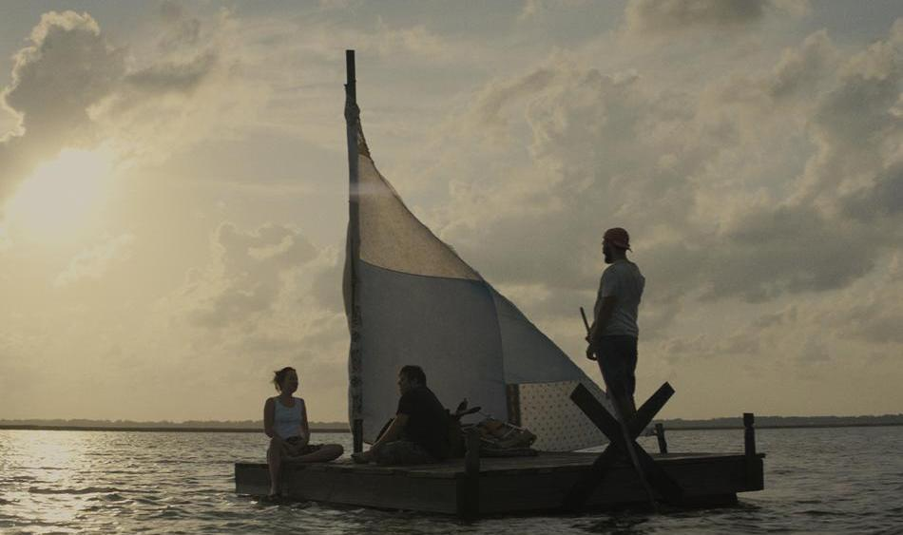
Specification details:
The Peanut Butter Falcon
Dir. Tyler Nilson and Michael Shwartz | Cert TBC |
93 mins | U.S. | 2019

Distributor: Signature Entertainment
Available: 18 October 2019 (theatrical)

Booking: Please email sales@signature-entertainment.co.uk

Synopsis:
The Peanut Butter Falcon is a modern Mark Twain-esque adventure starring Shia LaBeouf (American Honey, Fury) as a small-time outlaw turned unlikely coach who joins forces with Zak, a young man with Down Syndrome on the run from a nursing home with the dream of becoming a professional wrestler. Dakota Johnson (Suspiria, Fifty Shades of Grey) stars as Zak’s loving, but stubborn, carer.

From writer/director duo Tyler Nilson and Michael Shwartz the film also stars
Jon Bernthal (Baby Driver, Fury), Thomas Hayden Church (Sideways), Bruce Dern (Nebraska), John Hawkes (Three Billboards Outside Ebbing, Missouri) and introducing Zack Gottsagen as Zak.
Official Website: https://www.signature-entertainment.co.uk/film/the-peanut-butter-falcon/
Official Facebook: https://www.facebook.com/ThePeanutButterFalconMovie/
Official Twitter: @tpbfalcon
Distributor Twitter handle: @SignatureEntUK
Official hashtag: #ThePeanutButterFalcon
Official Instagram: https://www.instagram.com/peanutbutterfalcon/

Official UK Press assets: https://www.dropbox.com/sh/3ixmu1fsrbsyjji/AABW8KGqcSdVgTZkBcgFp1WRa?dl=0

Poster/stills: https://www.dropbox.com/sh/3ixmu1fsrbsyjji/AAAY3_8ahH6ROnLuFkFfmyPoa/PBF%20Approved%20Press%20Images.zip.cpgz?dl=0

Trailer YouTube version: https://youtu.be/0fdVhTUjHzI

Screener available on request. Please contact James@signature-entertainment.co.uk

Simple and easy wins for exhibitors

- Facebook and Instagram ads: this is an easy and effective way at reaching target audiences. FAN support can pay for the ad and we can also talk you through campaign set-up to maximise results.
- Local postcard distribution and postering in hangouts - pubs, clubs, SUs, cafes, venues, festivals

Promote your screenings

Find out how to tell new audiences about your events and make them unforgettable with our simple guides:

- A Simple Guide To: DIGITAL MARKETING: Marketing your events online can be as simple or as complex as you want it to be. To get you started, here are some easy steps to promote your event online.
- A Simple Guide To: AUGMENTING FILM SCREENINGS: Putting on a film screening doesn’t have to be about just showing a film. Venues can make their events stand out and attract new audiences by augmenting their screenings with something extra.

If running social media advertising, consider using the following key words/phrases to attract diverse audiences that might be interested in the film:
- Little Miss Sunshine
- Feel-good movies
- Dakota Johnson
- Shia LaBeouf
- Inclusive Cinema
- Down’s Syndrome

We expect The Peanut Butter Falcon to appeal to:

- Disabled audience members and their friends/family who will be interested in seeing a film where the lead actor is a young man with Down’s Syndrome
- Indie cinema lovers as the film is from the producers of Little Miss Sunshine
- Wrestling fans (stars wrestlers Jake Roberts and Mick Foley)
- Lovers of feel-good movies

The Peanut Butter Falcon: campaign and marketing ideas
The focus of BFI FAN’s support for new releases is developing diverse audiences:

- Price: If you have a young person/student ticket offer, why not promote it alongside The Peanut Butter Falcon
- Experience: Research into audiences highlights how important the whole experience is. Think about promoting guest speakers or post-film discussions along with your screenings.
- Interaction / social media: Focus on the fact that it is a film all about outsiders, something that will resonate with most audiences.

Inclusive Cinema assets for more accessible screenings:

Inclusive Cinema is a UK-wide project developed by the BFI Film Audience Network (FAN) designed to support screen exhibitors looking to host more accessible screenings.

With star Zack Gottsagen, we expect the film to appeal to some audience members with Down’s Syndrome as well as friends and family. Here are some assets from Inclusive Cinema that exhibitors might find useful if they’re planning on partnering with any local charities or Down’s organisations.

- Inclusive Cinema released an autism-friendly screenings guide earlier this year, in collaboration with Dimensions and UKCA. Obviously, this focuses specifically on the experiences of those with ASD, but many of the processes to address supporting audiences with additional needs are transferable. They also produced a quick relaxed screenings guide previous to this.

Other resources include:

- Opening our Doors presentation by Oska Bright - Welcoming learning disabled audiences
- Luminate Scotland - Ensuring your venues and events are accessible to all
- Culturehive - An accessible marketing guide
- Scope - End the Awkward campaign

Possible partners/guest speakers for screenings:

Signature Entertainment is partnering with the Royal MenCap Society for the film, but it makes sense to reach out to local/regional branches as well as:

- Scope
- DSA
- Media-wise
- Disability Arts
- Disability Horizons
- Learning Disability Today
- Members of the CEA Card and HYNT cards

There’s also a handful of leaders working with neurodiversity in cinema/arts (Oska Bright, Unlimited, Black Box Belfast, Dundee Contemporary Arts, Glasgow Film, Tyneside, Derby QUAD) who could share best practice or perhaps link us up to regular attendees with Down’s Syndrome who might be able to provide nice content/soundbites/interviews.

Event Ideas

- Engage local Downs/disability groups and put on special relaxed screenings
- Reach out to charities for potential guest speakers and/or special fund-raising screenings

Planning your event

There is a regional marketing freelancer in each Film Hub region working on grassroots outreach, press and marketing, alongside a small budget for activity. They will also be working with students (both foreign and home) and language schools. Get in touch on fannewreleases@watershed.co.uk to be linked in to the campaign in your area - we can help with event ideas, finding speakers and other grassroots marketing.

- Email template for schools/university/youth networks
- Email template for event screenings
- Email template for contacting venues

Press
Get in touch with local press for any special events with the below press release template alongside stills from the film.

Generic press template for local press and listings

AWARDS:

- SXSW’s Narrative Spotlight audience award

Key Press Quotes

“A sweet transcendentalist fantasy as sunny as its Southern backdrop” - Den of Geek

“The Peanut Butter Falcon is the absolute definition of a feel-good movie.” - Birth. Movies. Death.

“LaBeouf brings the soul to "The Peanut Butter Falcon," while Gottsagen brings the spirit. He has an undeniably charming screen presence, and the actor takes to this starring role with gusto.” - Los Angeles Times

ARTICLES OF INTEREST

FORBES: Why 'The Peanut Butter Falcon' Changes The Disabled Narrative & Scared Hollywood

https://www.forbes.com/sites/kristenlopez/2019/08/05/why-the-peanut-butter-falcon-changes-the-disabled-narrative--scared-hollywood/#6737a5ea3518

THE SPOOL: Navigating Disability With Grace

https://thespool.net/movies/2019/08/the-peanut-butter-falcon-review/

NATIONAL REVIEW: A Movie Star with Down’s Syndrome

https://www.nationalreview.com/2019/08/the-peanut-butter-falcon-actor-with-down-syndrome-gives-impressive-performance/

FILM COPY

Official Synopsis
A modern Mark Twain style adventure story, THE PEANUT BUTTER FALCON tells the story of Zak (Zack Gottsagen), a young man with Down syndrome, who runs away from a residential nursing home to follow his dream of attending the professional wrestling school of his idol, The Salt Water Redneck (Thomas Haden Church).
A strange turn of events pairs him on the road with Tyler (Shia LaBeouf), a small time outlaw on the run, who becomes Zak’s unlikely coach and ally. Together they wind through deltas, elude capture, drink whisky, find God, catch fish, and convince Eleanor (Dakota Johnson), a kind nursing home employee charged with Zak’s return, to join them on their journey.

SAMPLE SOCIAL MEDIA POSTS

Twitter/Instagram:
“A sweet transcendentalist fantasy as sunny as its Southern backdrop” - @DenOfGeek

Watch the feel-good movie of the year, @tpbfalcon from @SignatureEntUK. #ThePeanutButterFalcon

[VENUE]
[DATE]
[LINK]
A modern Mark Twain style adventure story and the definition of a feel-good movie - @SignatureEntUK’s @tpbfalcon starring @thecampaignbook and @zachrgottsagen. #ThePeanutButterFalcon

[VENUE]
[DATE]
[LINK]

Special event:
Join us for a post-show discussion on representation in film and about how Down’s Syndrome is misunderstood in today’s society. [DATE and CTA]

Facebook:

“A sweet transcendentalist fantasy as sunny as its Southern backdrop” - Den of Geek

The Peanut Butter Falcon is the feel-good movie of the year, starring Shia LaBeouf and newcomer Zack Gottsagen. #ThePeanutButterFalcon

Watch the trailer now and book tickets.

[LINK]

