Site Structure

Main Menu:
- Home
- About
- Data
- How-to guides
- Case Studies
- Assets
- Training
- Funding
- Contract

Audience Group & Action Menu (All standard pages):
- Ethnicity
  - Ethnicity
  - Research
  - Funding
  - Advocacy
  - Venue Planning
  - Training and recruitment
  - Programming
  - Marketing and Communication
  - Education
- Sexualty & Gender
  - Sexualty & Gender
  - Research
  - Funding
  - Advocacy
  - Venue Planning
  - Training and recruitment
  - Programming
  - Marketing and Communication
  - Education
- Migration
  - Migration
  - Home
  - Research
  - Funding
  - Advocacy
  - Venue Planning
  - Training and recruitment
  - Programming
  - Marketing and Communication
  - Education
- Poverty
  - Poverty
  - Research
  - Funding
  - Advocacy
  - Venue Planning
  - Training and recruitment
  - Programming
  - Marketing and Communication
  - Education
- Rural
  - Rural
  - Research
  - Funding
  - Advocacy
  - Venue Planning
  - Training and recruitment
  - Programming
  - Marketing and Communication
  - Education
- Mental Health
  - Mental Health
  - Research
  - Funding
  - Advocacy
  - Venue Planning
  - Training and recruitment
  - Programming
  - Marketing and Communication
  - Education
- Dementia
  - Dementia
  - Research
  - Funding
  - Advocacy
  - Venue Planning
  - Training and recruitment
  - Programming
  - Marketing and Communication
  - Education
- Disability
  - Disability
  - Research
  - Funding
  - Advocacy
  - Venue Planning
  - Training and recruitment
  - Programming
  - Marketing and Communication
  - Education
- Autism and Neurodiversity
  - Disability
  - Research
  - Funding
  - Advocacy
  - Venue Planning
  - Training and recruitment
  - Programming
  - Marketing and Communication
  - Education
- Carers
  - Disability
  - Research
  - Funding
  - Advocacy
  - Venue Planning
  - Training and recruitment
  - Programming
  - Marketing and Communication
  - Education
- Young people
  - Disability
  - Research
  - Funding
  - Advocacy
  - Venue Planning
  - Training and recruitment
  - Programming
  - Marketing and Communication
  - Education
- Older People
  - Disability
  - Research
  - Funding
  - Advocacy
  - Venue Planning
  - Training and recruitment
  - Programming
  - Marketing and Communication
  - Education

Volunteers

Layouts:
- Home
- Default
- Case Studies Listing and Details
- Contact

Main Content
Main Content With Downloads
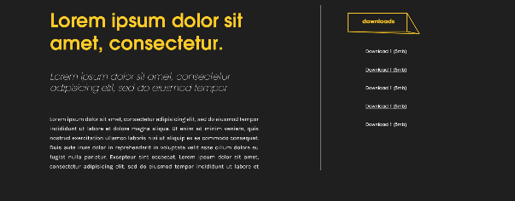

Quick Links
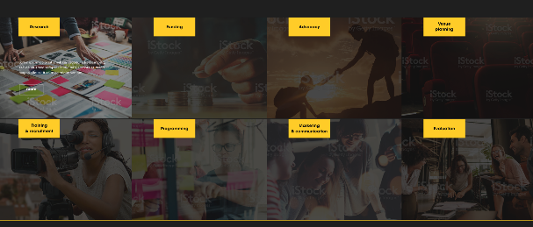

Gallery
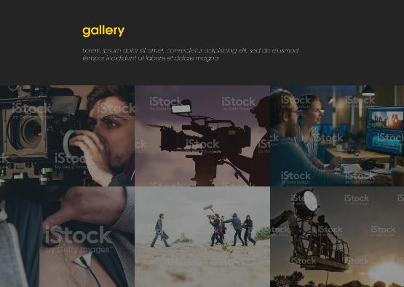

Quote

Case Studies
Choose 1 from Custom Post type

